Traveling Through the Math Practices
Hands on Math Activities
April 23, 2015
Jessica Adams & sandra Adkins
West Virginia Adult Basic Education

Introduction

West Virginia, like many other states, has been in the midst of reading, disseminating, and training with the new College and Career Readiness Standards for Adult Education (CCRS). Ms. Adams and Mrs. Adkins have been members of the WV Curriculum Design Committee since its inception in 2010. This committee was charged with determining how to implement the Common Core State Standards (CCSS) – now the CCRS – in adult education classrooms. As a result of the committee’s work, WV held an application-only Teacher Academy in 2013 and 2014. Additionally, the committee designed professional development in:
- NXT-GEN – Unwrapping Standards for Adult Education
- LESSON – Lesson Planning to Engage 21st Century Learners
- LESSON-SHOW – Comprehensive Lesson Demonstration
- DOK – Using Webb’s Depth of Knowledge to Inform Instruction
- UDL – Universal Design for Learning in the Adult Education Classroom
- SEAL – Strategies for Engaging Adult Learners
- MATH 1 – Exploring Key Shifts in the CCR Standards for Practice and Content
- Investigating Math Resources – Review of Curriculum Materials and MDC Materials
- WRITE 1 – Research-based Writing Strategies for College and Career Readiness

Three Shifts in Common Core Math Standards

Shift 1 – Focus: Focusing strongly where the standards focus
Shift 2 – Coherence: Designing learning around coherent progressions level to level
Shift 3 – Rigor: Pursuing conceptual understanding, procedural skill and fluency, and application—all with equal intensity

The Math Practices
“The Standards for Mathematical Practice (the Practices)—accepted in their entirety by the panel— describe habits of mind that mathematics educators at all levels of learning should seek to develop in their students. These practices rest on “processes and proficiencies” with established significance in mathematics education, including such skills as complex problem solving, reasoning and proof, modeling, precise communication, and making connections.”

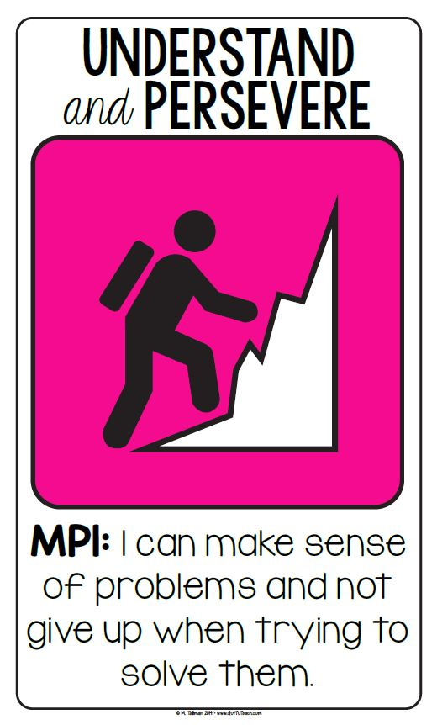

Make sense of problems and persevere in solving them. (MP.1)
Mathematically proficient students start by explaining to themselves the meaning of a problem and looking for entry points to its solution. They analyze givens, constraints, relationships, and goals. They make conjectures about the form and meaning of the solution and plan a solution pathway rather than simply jumping into a solution attempt. They consider analogous problems, and try special cases and simpler forms of the original problem in order to gain insight into its solution. They monitor and evaluate their progress and change course if necessary. Students might, depending on the context of the problem, transform algebraic expressions or change the viewing window on their graphing calculator to get the information they need. Mathematically proficient students can explain correspondences between equations, verbal descriptions, tables, and graphs or draw diagrams of important features and relationships, graph data, and search for regularity or trends. Less experienced students might rely on using concrete objects or pictures to help conceptualize and solve a problem. Mathematically proficient students check their answers to problems using a different method, and they continually ask themselves, “Does this make sense?” They can understand the approaches of others to solving complex problems and identify correspondences between different approaches.
Time Out to Determine the Digit
In the number puzzle the letters Q to Z represents a different digit from 0 to 9. Find the corresponding digits and letters. Be prepared to explain where you started, and the order in which you solved the puzzle.

- u * r = z
- t + w = t
- r + r + r + r = z
- x + y = q
- s * v = s
- $x^{2}=q$
- r + r = u
- x + u = s
- $\frac{y}{z}=\frac{x}{u}$

Time Out to Determine the Digit
Answer

- u * r = z
- t + w = t
- r + r + r + r = z
- x + y = q
- s * v = s
- $x^{2}=q$
- r + r = u
- x + u = s
- $\frac{y}{z}=\frac{x}{u}$

q = 9
r = 2
s = 7
t = 5
u = 4
v = 1
w = 0
x = 3
y = 6
z = 8

Four Square Graphic Organizer

Keywords | Diagram
# Sentence | Explanation

What do you already know?  What do you need to find? | Brainstorm ways  to solve this problem.
Try it here. | Explanations you need to include in your extended-response write-up. What did you learn by doing this problem?

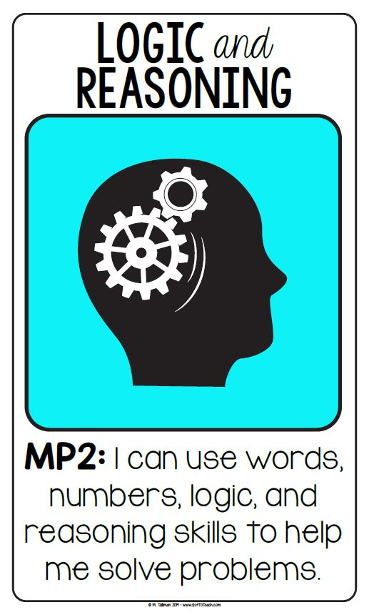

Reason abstractly and quantitatively. (MP.2)
Mathematically proficient students make sense of quantities and their relationships in problem situations. They bring two complementary abilities to bear on problems involving quantitative relationships: the ability to decontextualize—to abstract a given situation and represent it symbolically and manipulate the representing symbols as if they have a life of their own, without necessarily attending to their referents—and the ability to contextualize, to pause as needed during the manipulation process in order to probe into the referents for the symbols involved. Quantitative reasoning entails habits of creating a coherent representation of the problem at hand; considering the units involved; attending to the meaning of quantities, not just how to compute them; and knowing and flexibly using different properties of operations and objects.

Ratio and Proportions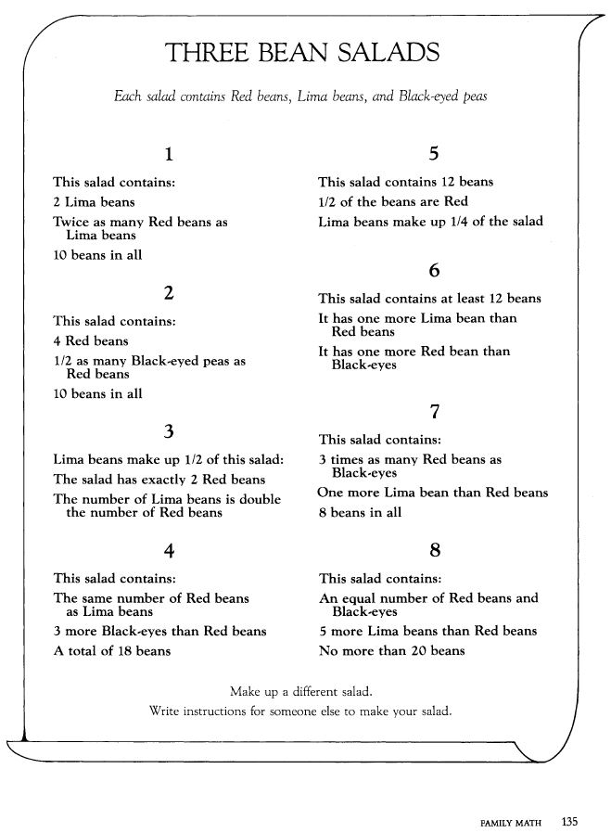

Algebra Tiles
Materials:
- Algebra tiles – 1 set per person

Directions:
- Instruct participants to examine the algebra tiles.
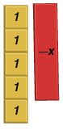
- Be sure to mention that one side of the tiles is always red. This represents a negative or opposite. Describe the “value” of each tile.
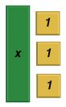
- Ask participants to show the following:
  - Five plus the opposite of x
  - Derek’s allowance plus $3.00
  - Five less than x plus (x)(y)

Zero Principle
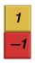
A number plus its opposite equals zero. Show one blue (1) tile and one red (-1) tile and explain that this is equal to 0.

Ask participants to show what tiles need to be added to the following to make zero:
- 2 red x tiles
- 1 red x tile and 3 unit tiles
- $2+x, if x=3$

Adding and subtracting
Tell participants to solve the following problems using the algebra tiles. Some explanation may be necessary when zero pairs come into play.
- $7+3$
- $7+1+(-4)$
- $2x+5+3x+$ 4
- $7-12$
- $\left(-8\right)-(-5)$

Multiplying and dividing
Inform participants that multiplying is making groups of a value.
- $3 (2)$
- $(-2)(3x)$
- $12 ÷6$

Multiplying polynomials
- Emphasize that rectangles must be built when multiplying polynomials.
- Demonstrate the set-up for $(2x)(x+1)$

Allow participants to show and solve the following:
- $\left(x+2\right)\left(x+1\right)$
- $\left(x-2\right)\left(x+1\right)$
- ${(x+3)}^{2}$
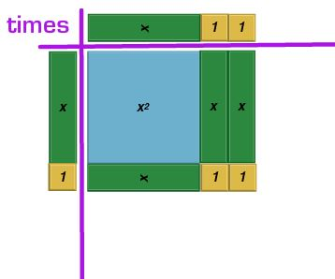
$$x^{2}+3x+2$$
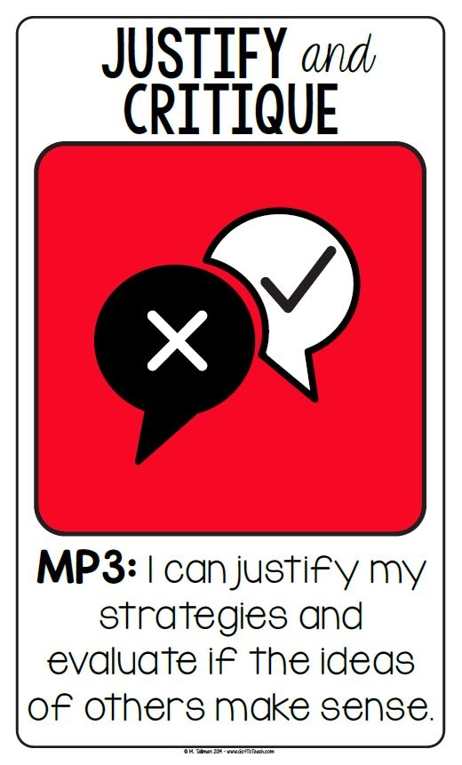

Construct viable arguments and critique the reasoning of others. (MP.3)
Mathematically proficient students understand and use stated assumptions, definitions, and previously established results in constructing arguments. They make conjectures and build a logical progression of statements to explore the truth of their conjectures. They are able to analyze situations by breaking them into cases, and can recognize and use counterexamples. They justify their conclusions, communicate them to others, and respond to the arguments of others. They reason inductively about data, making plausible arguments that take into account the context from which the data arose. Mathematically proficient students are also able to compare the effectiveness of two plausible arguments, distinguish correct logic or reasoning from that which is flawed, and—if there is a flaw in an argument—explain what it is. Less experienced students can construct arguments using concrete referents such as objects, drawings, diagrams, and actions. Such arguments can make sense and be correct, even though they are not generalized or made formal until later. Later, students learn to determine domains to which an argument applies. Students at all levels can listen or read the arguments of others, decide whether they make sense, and ask useful questions to clarify or improve the arguments.

“My Favorite No” Video Explanation

Ms. Leah Alcala is a math teacher at Martin Luther King Middle School in Berkeley CA. Her warm up routine includes what she calls “My Favorite No”. Please watch the video at Teaching Channel to see this in action. Here is a brief description:

1. Ms. Alcala puts a math problem on the board for students to work as they come into the classroom.
2. Students work the problem on an index card.
3. Time is called and students pass index cards to the front.
4. Ms. Alcala quickly goes through the cards, sorting into “yes” and “no” piles for “answer correct” and “answer incorrect”.
5. Of the “no” pile she chooses one card as her favorite “no” – in which a student has made a mistake. The mistake could be one that you are looking for or the most commonly made mistake.
6. Ms. Alcala then re-writes the problem on the class overhead (this protects student identity) and asks the students to find the mistake(s).

Using this regularly lets students critique the reasoning of others and evaluate if the ideas of others makes sense. Students can also justify their own strategies.
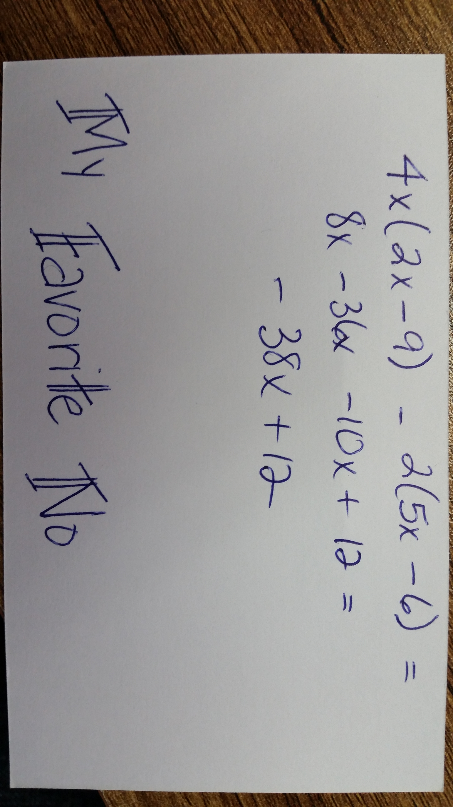
Number Line

Materials:
- String or yarn
- Tape or other way to hang “line”
- Clothes pins
- Index cards with pictures/numbers to be placed along number line

Directions:
- Hang string/yarn across a wall.
- Place index card with number “0” at the center of the line.
- As participants enter the room, hand each one an index card and clothes pin.
- Ask them to place their card along the number line in the appropriate place.
- Encourage discussion among the participants.
- Cards may even need to be rearranged as more cards are displayed.

Discussion:
Reflect on the activity with the participants.
- Ask what was difficult about the task, what was easy?
- What types of discussions did they have with each other?
- How did they defend their placement or provide reasoning?

Explain that this activity can be tailored to meet the needs of the students.
- Use only fractions, decimals, etc.
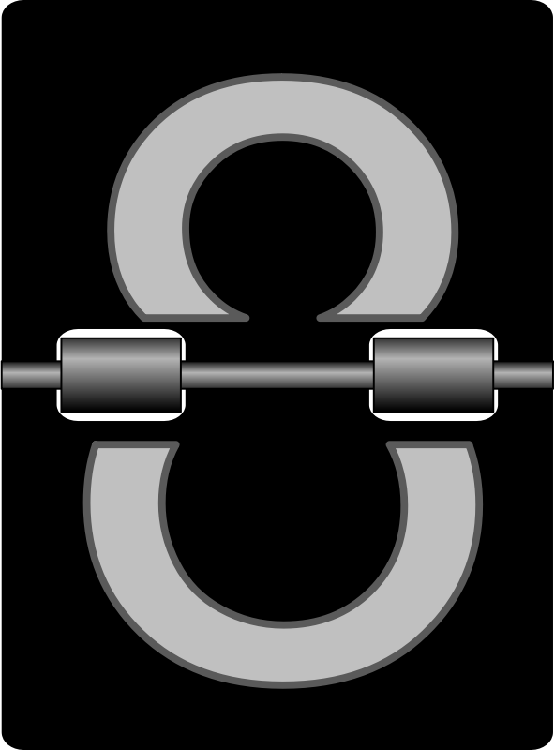
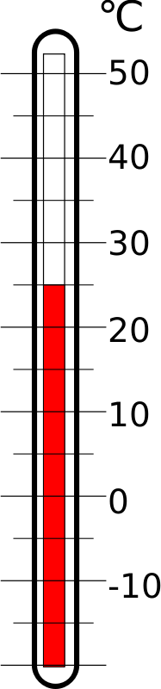
- Provide more complex concepts to higher level students, etc.

$\frac{π}{2}$

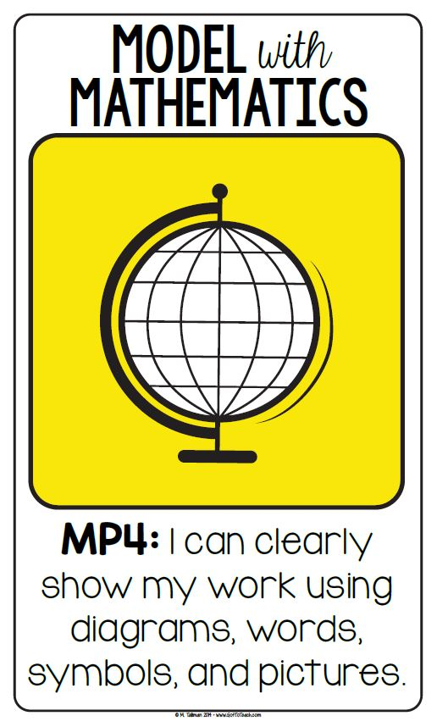

Model with mathematics. (MP.4)
Mathematically proficient students can apply the mathematics they know to solve problems arising in everyday life, society, and the workplace. This might be as simple as writing an addition equation to describe a situation. A student might apply proportional reasoning to plan a school event or analyze a problem in the community. A student might use geometry to solve a design problem or use a function to describe how one quantity of interest depends on another. Mathematically proficient students who can apply what they know are comfortable making assumptions and approximations to simplify a complicated situation, realizing that these may need revision later. They are able to identify important quantities in a practical situation and map their relationships using such tools as diagrams, two-way tables, graphs, flowcharts and formulas. They can analyze those relationships mathematically to draw conclusions. They routinely interpret their mathematical results in the context of the situation and reflect on whether the results make sense, possibly improving the model if it has not served its purpose.

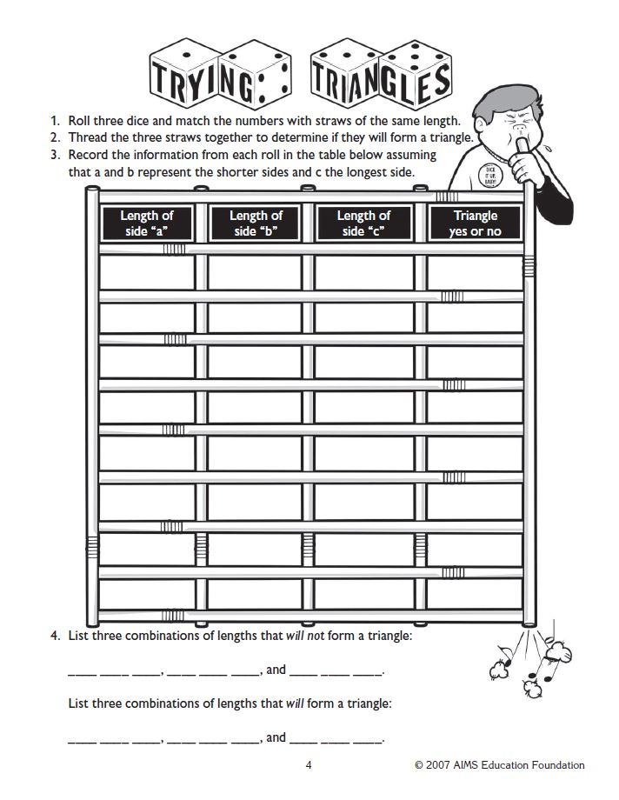
Trying Triangles Activity
Cuisenaire Rods
Materials:
- Cuisenaire rods
- Graph paper (optional)
- Colored pencils/crayons (optional)

Directions:
- Instruct students to start with the rods equal to 2 units (red).
- Have them find how many combinations they create using only one color that is equal to the larger rod.
- If available, they may draw the visual on their graph paper.
- Allow participants to repeat this process up to the 10 rod, listing all combinations that work.

Discussion:
- Show participants how this relates to multiplication. __x__ groups of __y__.
- Also, highlight the fact that when the only combination uses the white rod (1 unit), this represents a Prime Number.

Example:

How Long? How Many?

Math skills: This two-person game involves probability and strategy, and gives students experience with multiplication in a geometric context.

The object: To make rectangular arrays with Cuisenaire Rods and place them on 10-by-10 centimeter grids until no more space is available. The game encourages students to think strategically as they consider where to place their rectangles to avoid being blocked.

How to play: Students need Cuisenaire rods, one die and a grid sheet for each (Make a 10cm by 10cm grid. Also leave space for students to record how many of their squares are covered and uncovered).

The rules:
- On his or her turn, a player rolls the die twice to determine which Cuisenaire Rod to take. The first roll tells “how long” a rod to use. The second roll tells “how many” rods to take.
- Players arrange their rods into a rectangle, place it on their grid, and trace it (or if enough rods, they can be left on the grid). The write the multiplication sentence inside.
- The game is over when one player can’t place a rectangle because there’s no room on the grid. Then players figure out how many of their squares are covered and how many are uncovered and check each other’s answers.

Discussion:
After students had had experience playing the game, talk with them about strategies for placing rectangles and figuring out their final scores.

Multiplication Sentence:

3 x 2 = 6
4 x 5 = 20
2 x 1 = 2
5 x 3 = 15
2 x 4 = 8
3 x 5 = 15

3 X 2 |  |  |  |  | 5 x 3
4 x 5
 |  |  |  | 2 x 4 |  | 3 x 5
2 x 1

Example:
- Student 1 rolls a 3 the first time – this is the “how long”. On the second roll Student 1 rolls a 2 – this the “how many”. Student one will take out 2 green rods and place them on the board and writes the multiplication sentence on the grid (if tracing) or to the side of the grid (if leaving rods out).
- Student 2 rolls a 4 the first time and a 5 the second time. Student 2 will take out 5 purple rods to place on the board writes the multiplication sentence on the grid (if tracing) or to the side of the grid (if leaving rods out).
- Student 1 now rolls a 2 and a 1. Student 1 will take out 1 red rod and place it on the board writes the multiplication sentence on the grid (if tracing) or to the side of the grid (if leaving rods out).
- Student 2 rolls a 5 and then a 3. Student 2 will take out 3 yellow rods writes the multiplication sentence on the grid (if tracing) or to the side of the grid (if leaving rods out).
- Student 1 rolls a 2 and then a 4. Student 1 will take out 4 red rods writes the multiplication sentence on the grid (if tracing) or to the side of the grid (if leaving rods out).
- Student 2 rolls a 3 and then a 5. Student 2 will take out 5 green rods writes the multiplication sentence on the grid (if tracing) or to the side of the grid (if leaving rods out).

How Long? How Many?

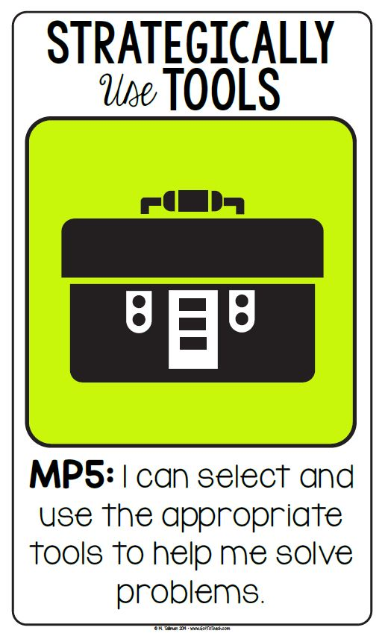

Use appropriate tools strategically. (MP.5)
Mathematically proficient students consider the available tools when solving a mathematical problem. These tools might include pencil and paper, concrete models, a ruler, a protractor, a calculator, a spreadsheet, a computer algebra system, a statistical package, or dynamic geometry software. Proficient students are sufficiently familiar with tools appropriate for their course to make sound decisions about when each of these tools might be helpful, recognizing both the insight to be gained and their limitations. For example, mathematically proficient students analyze graphs of functions and solutions generated using a graphing calculator. They detect possible errors by strategically using estimation and other mathematical knowledge. When making mathematical models, they know that technology can enable them to visualize the results of varying assumptions, explore consequences, and compare predictions with data. Mathematically proficient students at various levels are able to identify relevant external mathematical resources, such as digital content located on a website, and use them to pose or solve problems. They are able to use technological tools to explore and deepen their understanding of concepts.

Broken Ruler Activity

Materials:
- Objects to be measured
- Broken Rules (use printed on card stock)
- Recording Sheet
- Optional: Actual broken rules, yardsticks, tape measures

Directions:
- Give each student a broken ruler and a recording sheet.
- You can make your own recording sheet for items found in/around your classroom.
  - How tall is the classroom door?
  - What is the diagonal measurement of the computer screen?
  - What is the area of the teacher’s desk?
  - How tall is a stack of 10 pennies?
  - What is the circumference of the Achieve Math book?
  - How tall is the computer chair?
  - How big is the mailbox (length and width)?
- When everyone is done, compare? Did everyone get the same answer? Why? Why not?

Notes:
- The challenge is for the students to use the tool that they are given correctly.
- The activity is improved when a variety of broken rulers are used to see if students can use a measurement device that starts at “3” instead of “0”.
- If one ruler measures in inches and another in centimeters this could add a challenge as to why different students arrive at different numbers.

1
1
2
3
4
5
6
7
4
5
6
7
8
9
10
2
3
4
5
6
7
8
3
4
5
6
7
8
9
5
6
7
8
9
10
11
0
1
1
3
4
5
6
1
2
3
4
5
6
7

Making Trail Mix

Materials:
- Recipe card
- Measuring supplies (varies based on recipe)
- Food items (cereal, raisins, etc.)
- Bowl

Directions:
- Give each group of students a recipe card and appropriate measuring tools.
- Ask them to make the trail mix as directed (must be enough for the table to share).

Discussion:
- Explain how recipes can be differentiated to students’ skill levels.
- Can use ratios, fractions, conversions (ounces to cups).
- Compare composition of all trail mixes to show that they are similar regardless of the measurement tool used.

Trail Mix Recipe  Standard Measuring Cups  2 cups Cheerios  2 cups Chex  1 cup raisins  ½ cup chocolate chips  Mix together all ingredients. Enjoy! | Trail Mix Recipe  Solo Cups  2 cups Cheerios  2 cups Chex  1 cup raisins  ½ cup chocolate chips  Mix together all ingredients. Enjoy!
Trail Mix Recipe  Small Containers  16 oz Cheerios  16 oz Chex  8 oz raisins  4 oz chocolate chips  Mix together all ingredients. Enjoy! | Trail Mix Recipe  ¼ cup measuring cup only  16 oz Cheerios  16 oz Chex  8 oz raisins  4 oz chocolate chips  Mix together all ingredients. Enjoy!
Trail Mix Recipe
Large Containers

4 parts Cheerios
4 parts Chex
2 parts raisins
1 part chocolate chips

Mix together all ingredients. Enjoy!

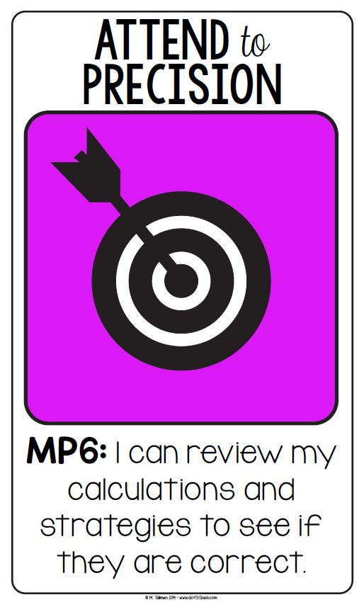

Attend to precision. (MP.6)
Mathematically proficient students try to communicate precisely to others. They try to use clear definitions in discussion with others and in their own reasoning. They state the meaning of the symbols they choose, including using the equal sign consistently and appropriately. They are careful about specifying units of measure, and labeling axes to clarify the correspondence with quantities in a problem. They calculate accurately and efficiently, express numerical answers with a degree of precision appropriate for the problem context. Less experienced students give carefully formulated explanations to each other. By the time they reach high school they have learned to examine claims and make explicit use of definitions.

Paid in Pennies Activity

Materials:
- Worksheet
- Calculators
- Graph paper (optional)

Directions:
- Ask the participants the question printed at the top of the worksheet.
- Have each of them decide which plan they would choose and why before beginning the activity.
- Next, allow them time to fill in the chart to find the total salary for each plan.
- If time allows, ask them to work through the questions of the back of the page.
- They may also create a graph showing where the rates begin to change (if at all).

Discussion:
- Ask participants to discover a mathematical word to describe the process that occurs in this type of problem.
- Have them focus on using correct mathematical vocabulary while discussion with others at the table.
- Have them talk about what is meant by “rate”.
- Make sure participants recognize that Plan B must be converted to dollars to be able to compare with Plan A.

Would You Rather…?

Before beginning a new contract job with ABC Company you must choose how you would like to be paid. You may choose:
- Plan A to be paid $10,000 a week for 28 weeks …OR…
- Plan B to start with 1¢ the first week and double each week thereafter.

Once you have chosen your Payment Plan, you may not change it. I choose Plan _________

Week | Plan A | Plan B
1
2
3
4
5
6
7
8
9
10
11
12
13
14
15
16
17
18
19
20
21
22
23
24
25
26
27
28
TOTAL | $ | $

Mental Math War

Materials:
- Deck of cards for every two students

Directions:
- Remove all face cards from the decks.
- Aces are equal to 1.
- Students are given an operation to complete when flipping cards over (add, subtract, multiply divide, algebra equation, etc.).
- Whoever correctly answers the mathematical computation correctly wins the cards.
- Whomever has the most cards when time is called, wins.

Discussion:
If using algebra equations, be sure to specify which person is the x and which is the y.

**Many variations using a card deck can be found at: Let’s Play Math

Why should students practice with Mental Math?

“Mental Math War develops students’ capacity for “mental math” and enhances their fluency with numbers, expressions, and equations”

ADD | SUBTRACT
MULTIPLY | DIVIDE
2X + Y | X + 3Y
2X – 2Y | 4X – Y

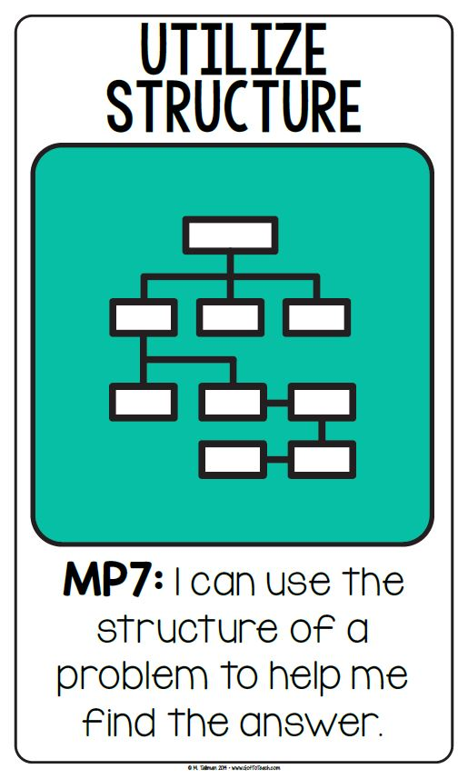

Look for and make use of structure. (MP.7)
Mathematically proficient students look closely to discern a pattern or structure. Students, for example, might notice that three and seven more is the same amount as seven and three more, or they may sort a collection of shapes according to how many sides the shapes have. Later, students will see 7 × 8 equals the well-remembered 7 × 5 + 7 × 3, in preparation for learning about the distributive property. In the expression x 2 + 9x + 14, students can see the 14 as 2 × 7 and the 9 as 2 + 7. They recognize the significance of an existing line in a geometric figure and can use the strategy of drawing an auxiliary line for solving problems. They also can step back for an overview and shift perspective. They can see complicated things, such as some algebraic expressions, as single objects or as being composed of several objects. For example, they can see 5 – 3(x – y) 2 as 5 minus a positive number times a square and use that to realize that its value cannot be more than 5 for any real numbers x and y.

Learning Integer Rules
Materials:
- 1 bag of black beans
- 1 bag of white beans
- Approximately 10 beans of each color

Lesson:
Part 1: Combining Positive Integers
- Have students place the positive (white) beans on their desk
- Demonstrate 1 or 2 examples, having student duplicate with their beans
- Example: 2 + 3
  - Set out 2 positive (white) beans and 3 positive (white) beans
  - Now combine them into one pile
  - Ask, “How many beans are there?” (5 beans)
  - Ask, “Positive or negative?” (Positive)
  - Say, “So when we combine positive 2 and positive 3 we get what?” (Positive 5)

Part 2: Combining Negative Integers
- Have students place the negative (black) beans on their desk
- Demonstrate 1 or 2 examples, having student duplicate with their beans
- Example: (-2) + (-3)
  - Set out 2 negative (black) beans and 3 negative (black) beans
  - Now combine them into one pile
  - Ask, “How many beans are there?” (5 beans)
  - Ask, “Positive or negative?” (Negative)
  - Say, “So when we combine negative 2 and negative 3 we get what?” (Negative 5)

Part 3: Combining Positive and Negative Integers
- Students should have 2 piles of beans – one while pile and one black pile
- Review the concept of zero pair (1 positive and 1 negative combined = zero)
- Demonstrate 3 or 4 examples, having students duplicate with their beans (make sure your examples include both positive and negative numbers)
- Example: 2 + (-3)
  - Set out 2 positive (white) beans and 3 negative (black) beans
  - Now combine them into one pile
  - Ask, “Are there any zero pairs?” (Yes, 2 of them)
  - Ask, “What do we do with zero pairs?” (Get rid of them)
  - Students should get rid of the zero pairs
  - Ask, “How many beans are remaining?” (1 bean)
  - Ask, “What kind of bean is it?” (Negative)
  - Say, “So when we combine positive 2 and negative 3 we get what?” (Negative 1)

Other Sample Combining Integer Problems
Adding Positive Integers
5 + 3
7 + 2
4 + 2 + 3
Adding Negative Integers
-5 + -2
-3 + -3 + -2
-7 + -2
Adding Positive and Negative Integers
9 + -6
-3 + 6 + (-1)
7 + (-3)
(-4) + 6

Learning to Subtract Negative Integers

Materials:
- 3x5 index cards (9 per student)
- 3x5 colored index card (1 per student)
- Markers

Lesson:
- Students need 9 index cards. On one side of the index card they will write the positive numbers of 1 – 9. Each card will be flipped over and the corresponding negative number will be written on the back of the card (can be done in different color if desired).
- Student will use the colored index card to write + (for addition) on the front and – (for subtraction) on the back.
- Say, “If we think of a number line, when we add numbers we move to the right but when we subtract numbers we change direction and go to the left – in the opposite way.”
- Say, “So to subtract an integer, add its opposite.”
- Example: (-6) – (-5) becomes (-6) + (+5)
  - Using their cards for this example, the student places the -6 card on the table, place the colored subtraction card on the table and then the -5 card on the table.
  - Have the student model subtracting an integer by adding the opposite integer.
  - The student should flip over the subtraction to addition and the -5 to a +5.
  - Now the rules of addition of integers can be followed. (-6) + (+5) = -1
  - You can have the students say, “change, change” as they flip the two cards.

Practice:

8 – (-3)
6 – (-6)
5 – (+8)
-5 – (-7)
-5 – (+3)
-4 – (+3)

Woozles Attribute Card Game

Woozle Attributes

- Shape - Straight or curved
- Color – blue or orange
- Dots – One or two
- Hair – bald or fuzzy

Woozles deck: 32 Woozles cards (run 4 copies of the black line master on cardstock -2 sheets on one color and 2 sheets on a contrasting color – cut apart OR you can print on white card stock and outline in 2 different colors)

Players – 2 - 4
- Shuffle the cards and stack them into a deck face down.
- Deal 9 cards from the top of the deck into a 3 X 3 array for all to see.
- The person to the left of the dealer begins.
- Each player may remove one pair per turn.
- The empty spaces in the array are filled with the cards from the top of the deck.
- If a player cannot find a pair that can be removed, the player passes.
- Play continues with players taking turns until either all of the cards are removed in pairs or the array contains no pairs that can be removed (or some predetermined time period expires).

1st round – pairs are removed with only 1-difference – example: a curved, blue, hairy, one dot woozle paired with a curved, orange, hairy, one dot woozle
2nd round – pairs are removed with 2-difference – example: a curved, blue, hairy, one dot woozle paired with a straight, orange, hairy, one dot woozle
3rd round – pairs are removed with 3-difference (or one-alike) – example: a curved, blue, hairy, one dot woozle paired with a straight, orange, bald, one dot woozle
4th round – pairs are removed with 4-difference (or no attributes in common) – example: a curved, blue, hairy, one dot woozle paired with a straight, orange, bald, two dot woozle

The number of pairs captured by each player is counted after each round and recorded as the score for each player. The cards are then shuffled and the next round played. At the end of all 4 rounds, the player with the highest score wins.

A shorter version of the game can be played by choosing any of the types of pairings described in rounds 1, 2, 3, or 4 and going through the deck only one time.
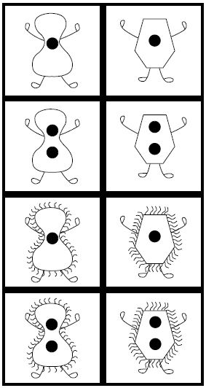
Make two copies for each
set of Woozle Cards. Use
white or off-white card stock.
Before laminating, color one
set blue and the other set
red. Trace around the inside
of each Woozle with a
marker, leaving the rest of
the creature white. Coloring
the entire Woozle may
obscure the dots.

BLM 44—Woozle cards

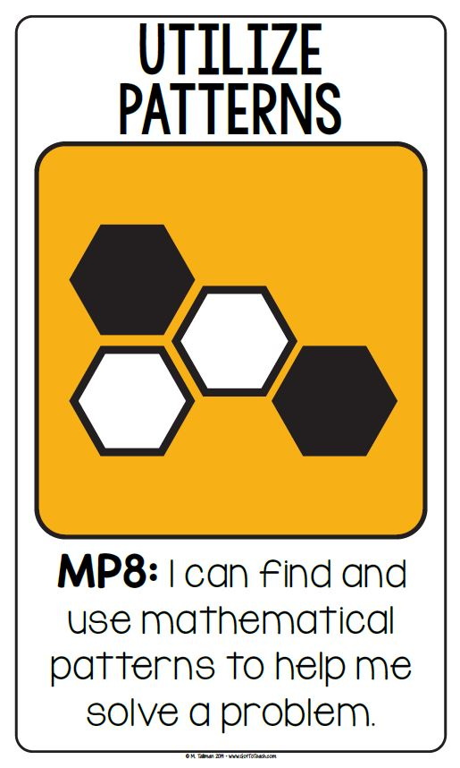

Look for and express regularity in repeated reasoning. (MP.8)
Mathematically proficient students notice if calculations are repeated, and look both for general methods and for shortcuts. Early on, students might notice when dividing 25 by 11 that they are repeating the same calculations over and over again, and conclude they have a repeating decimal. By paying attention to the calculation of slope as they repeatedly check whether points are on the line through (1, 2) with slope 3, students might abstract the equation (y – 2)/(x – 1) = 3. Noticing the regularity in the way terms cancel when expanding (x–1)(x+1), (x–1)(x 2 +x+1), and (x–1)(x 3 +x 2 +x+1) might lead them to the general formula for the sum of a geometric series. As they work to solve a problem, mathematically proficient students maintain oversight of the process, while attending to the details. They continually evaluate the reasonableness of their intermediate results.

Fraction Strips
Materials:
- 6-7 Strips of paper (equal lengths, approximately 1 inch wide)
- Fraction Strip Activity Worksheet

Directions:
- Instruct participants to label the first strip with the number 1 (represent 1 whole).
- For the next strip, have them fold it in half. Label each section ½.
- Continue process to create ¼ and 1/8.
- Demonstrate using strips to add, subtract, and multiply fractions.
- Allow participants time to work through the worksheet.

Discussion:
- Remind students to think of multiplication as ___ of ___ (when multiplying a fraction by a fraction – ½ x 2/3 = ½ of 2/3?).
- When dividing, think of it as how many ___ in ___ (3 divided by ¼ = how many ¼’s in 3?).

Fraction Strip Activity

Use your fraction strips to answer the following questions:

1. How many eighths equal one whole?

2. What is $\frac{1}{2}$ + $\frac{3}{4}$ ?

3. What is $1 \frac{1}{4}- \frac{3}{8 }$ ?

4. What is $2 \frac{1}{4} × \frac{1}{2}$ ?

5. What is $\frac{1}{4} ×3$ ?

6. What is $\frac{3}{4}+ \frac{3}{8}$ ?

Visualizing Fraction Division

Try the following problems by creating a visual model. Think “how many ___ are in ___” or “if I split ___ things into ___ equal groups, how many in each group?”

1. $2\frac{3}{4} ÷ \frac{1}{2}$

2. $2 ÷ \frac{1}{4}$

3. $10 ÷2\frac{1}{4}$

4. $\frac{1}{4}÷3$

5. $2\frac{3}{4} ÷2$

6. $\frac{3}{4} ÷1\frac{1}{2}$

Fraction Strips

1
1/2 |  |  |  |  |  |  |  |  |  |  |  | 1/2
1/3 |  |  |  |  |  |  |  | 1/3 |  |  |  |  |  |  |  | 1/3
1/4 |  |  |  |  |  | 1/4 |  |  |  |  |  | 1/4 |  |  |  |  |  | 1/4
1/5 |  |  |  |  | 1/5 |  |  |  |  | 1/5 |  |  |  | 1/5 |  |  |  |  | 1/5
1/6 |  |  |  | 1/6 |  |  |  | 1/6 |  |  |  | 1/6 |  |  |  | 1/6 |  |  |  | 1/6
1/8 |  |  | 1/8 |  |  | 1/8 |  |  | 1/8 |  |  | 1/8 |  |  | 1/8 |  |  | 1/8 |  |  | 1/8
1/10 |  | 1/10 |  |  | 1/10 |  | 1/10 |  |  | 1/10 |  | 1/10 |  | 1/10 |  |  | 1/10 |  | 1/10 |  |  | 1/10
1/12 | 1/12 |  |  | 1/12 |  | 1/12 |  | 1/12 |  |  | 1/12 | 1/12 | 1/12 |  |  | 1/12 |  | 1/12 |  | 1/12 |  |  | 1/12

Quantity: Part-to-Whole with Pattern Blocks

Make the shape of a hexagon (yellow) with only trapezoids (red). How many do you need? ____
Write a fraction equivalent to 1 hexagon that will show the number of trapezoids you used. ____
1 trapezoid = ____ of 1 hexagon

Make the shape of a hexagon (yellow) with only rhombuses (blue). How many do you need? ___
Write a fraction equivalent to 1 hexagon that will show the number of rhombuses you used. ____
1 rhombus = ____ of 1 hexagon

Make the shape of a hexagon (yellow) with only triangles (green). How many do you need? ____
Write a fraction equivalent to 1 hexagon that will show the number of triangles you used. ____
1 triangle = ____ of 1 hexagon

Make the shape of a trapezoid (red) with only triangles (green). How many do you need? ____
Write a fraction equivalent to 1 trapezoid that will show the number of triangles you used. ____
1 triangle = ____ of 1 trapezoid

Answer these questions using 1 block:
2 rhombuses + __________________ = 1 whole (hexagon)
$\frac{1}{2}+ \frac{1}{6}+$______________ = 1 whole (hexagon)
$\frac{3}{6}+ \frac{1}{6}+$______________ = 1 whole (hexagon)
Why did these examples all need the same shape? ____________________________________

Answer these questions using 2 blocks:
2 rhombuses + __________________ = 1 whole (hexagon)
$\frac{1}{2}+ \frac{1}{6}+$______________ = 1 whole (hexagon)
$\frac{3}{6}+ \frac{1}{6}+$______________ = 1 whole (hexagon)
Why did these examples all need two of the same shape? _______________________________

Which is more, 5 triangles or 3 rhombuses? Show it with a drawing and write an inequality to represent it.

Which is more, 2 rhombuses or 1 trapezoid? Show it with a drawing and write an inequality to represent it.

Which is more, 3 triangles or 1 trapezoid? Show it with a drawing and write an equation to represent it.

1 Hexagon Challenge:
Show 1 hexagon with as many different combinations of trapezoids, rhombuses, and triangles as possible. Write down the equation that goes with each combination.

½ Hexagon Challenge:
Show ½ hexagon with as many different combinations of trapezoids, rhombuses, and triangles as possible. Write down the equation that goes with each combination.

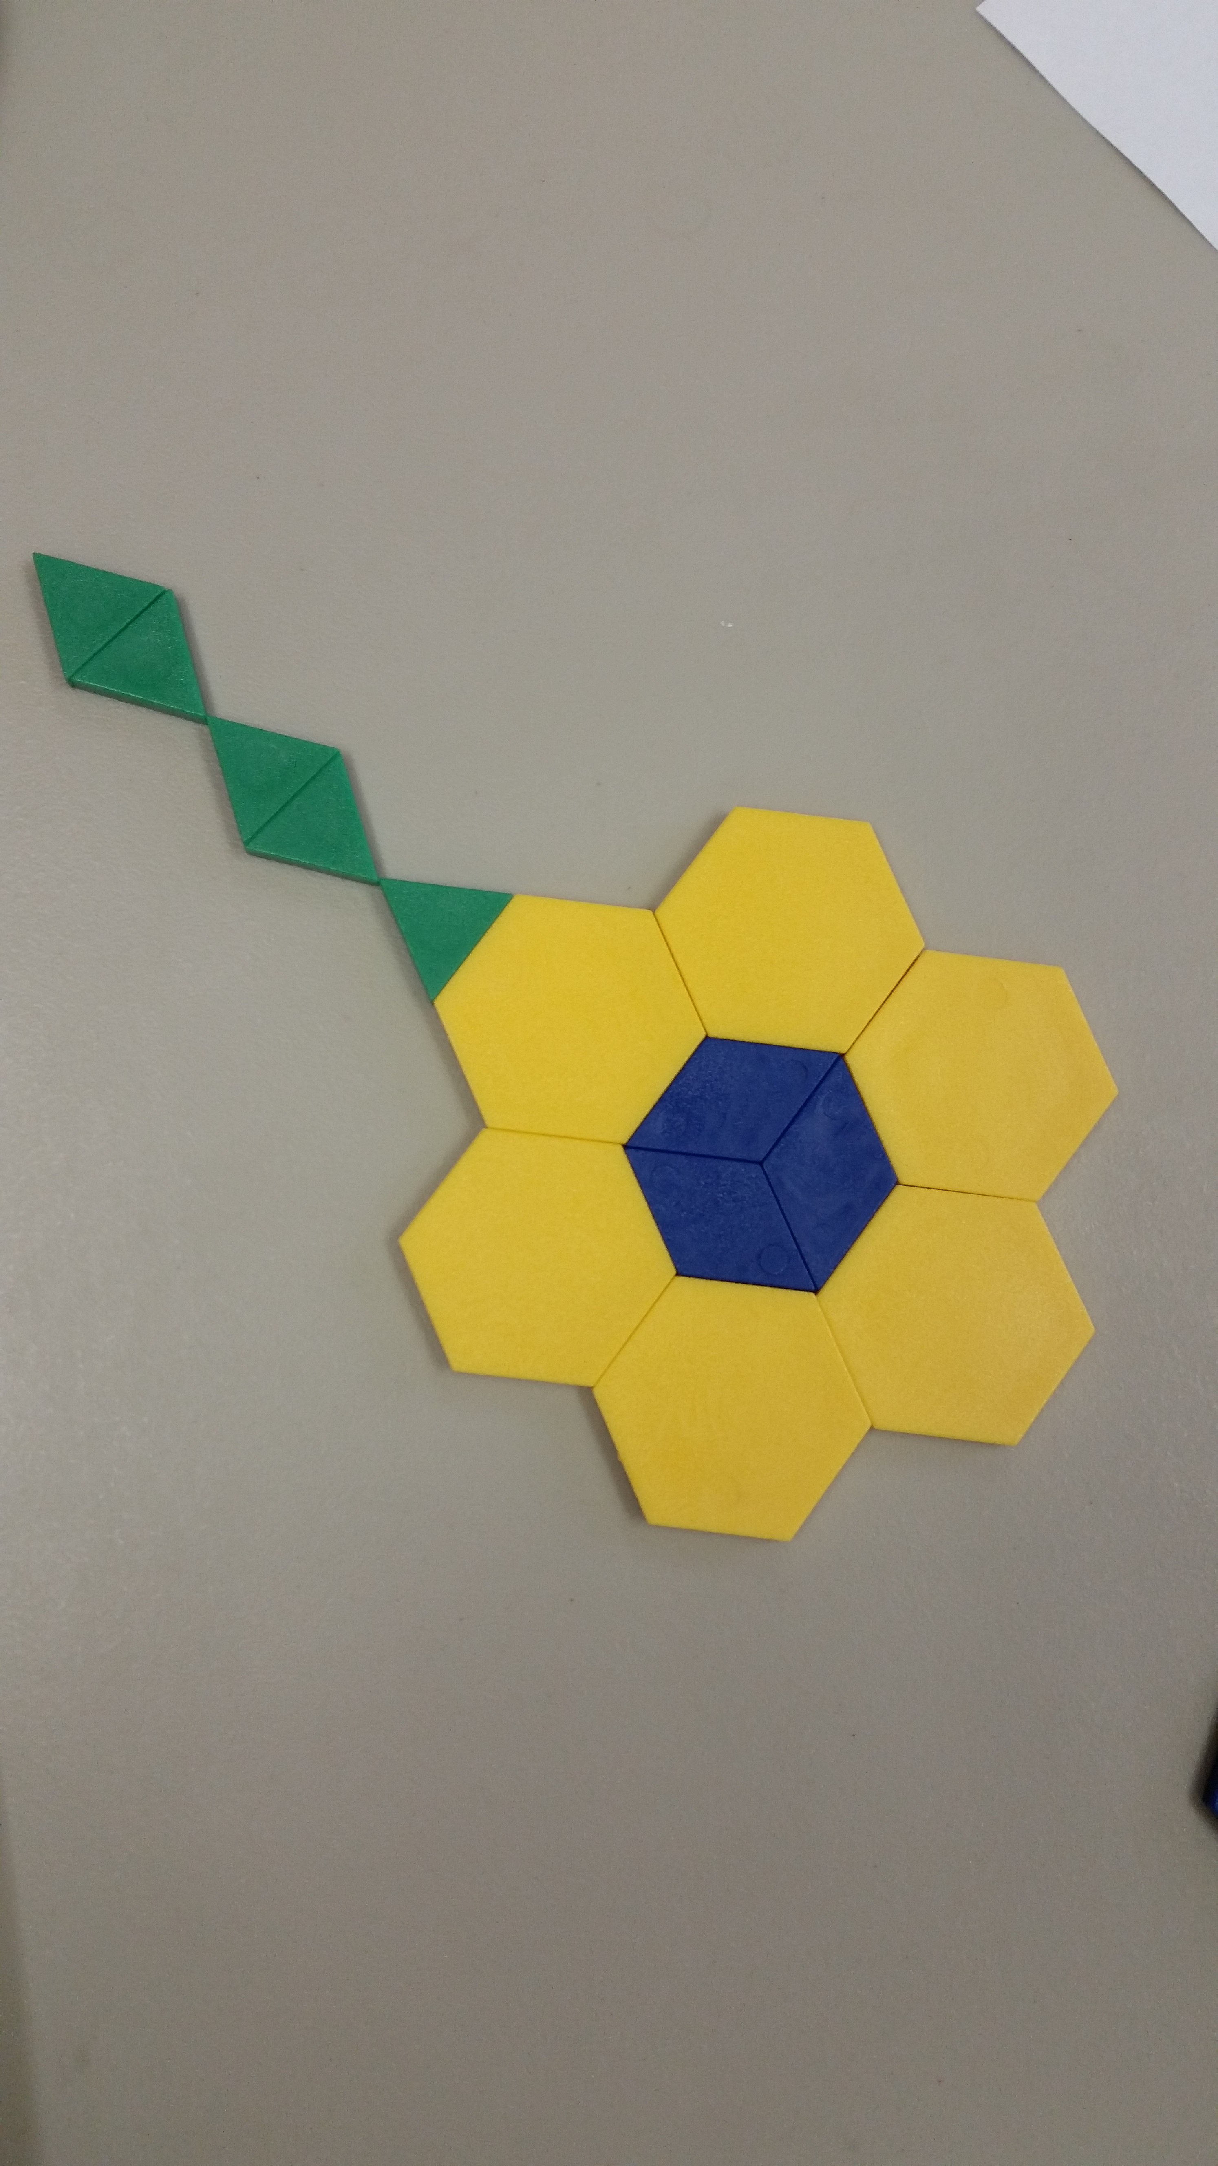

Using the picture above, determine what part of the whole flower is
Hexagon (yellow) ______________
Rhombus (blue) _______________
Triangle (green) _______________

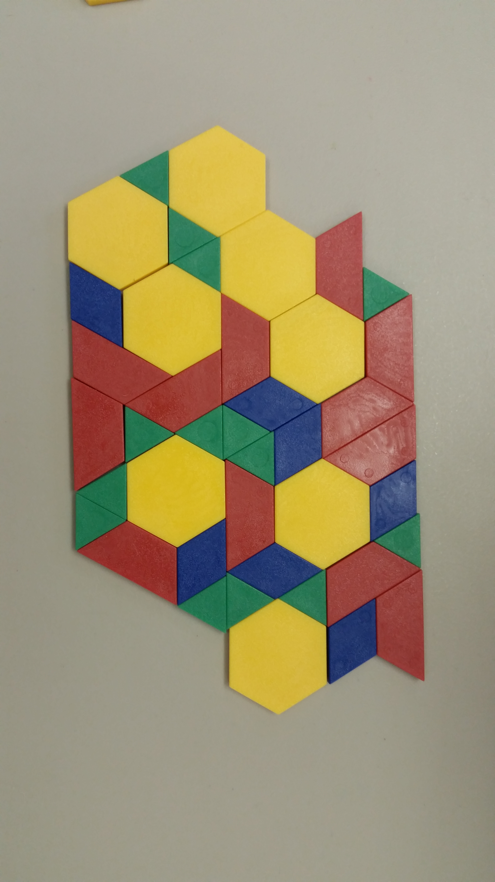

Using the picture above, determine what part of the whole design is

Hexagon (yellow) ______________
Rhombus (blue) _______________
Triangle (green) _______________
Trapezoid (red) ______________

References
4 Great Math Games. (2015, April 8). Retrieved from Schoolastic: http://teacher.scholastic.com/lessonrepro/lessonplans/grmagam.htm
AIMS Education Foundation. (2013). Trying Triangles. Fresno, CA, United States of America: AIMS Education Foundation.
AIR, RTI International. (2014, March). TEAL Math Works! Guide. Retrieved from LINCS Literacy Information and Communication System: https://teal.ed.gov/sites/default/files/Teal_Math_Works_Guide_508.pdf
Alcala, L. (n.d.). My Favorite No: Learning from My Mistakes. Retrieved from Teaching Channel: https://www.teachingchannel.org/videos/class-warm-up-routine
Gaskins, D. (2015, April 10). The Game That Is Worth 1000 Worksheets. Retrieved from Let's Play Math: http://letsplaymath.net/2006/12/29/the-game-that-is-worth-1000-worksheets/
Kero, M. (n.d.). Four Square Technique for Solving Math Word Problems. Retrieved from eHow: http://www.ehow.com/video_12242420_four-square-technique-solving-math-word-problems.html
Pimentel, S. (2013, April). Publications: LINCS. Retrieved from Literacy Information and Communication System: https://lincs.ed.gov/publications/pdf/CCRStandardsAdultEd.pdf
PIMSER. (2010, March 09). Retrieved from Partnership Institute for Math and Science Education Reform: http://www2.research.uky.edu/pimser/p12mso/pub/2009-10%20Archives/Math%20Leadership%20Support%20Network%20%28MLSN%29%202009-10/By%20Month/March%202010/Woozle%20Rules[1].docx?Mobile=1&Source=%2Fpimser%2Fp12mso%2F_layouts%2Fmobile%2Fview.aspx%3FList%3D0c46d
Schmitt, M. J., Steinback, M., Merson, M., Donovan, T., & Kliman, M. (2004). Using Benchmarks: Fractions, Decimals, and Percents (EM Power Series). Cambridge: Key Curriculum Press.
Silver, H. F., Brunsting, J. R., Walsh, T. J., & Edward, T. (2012). Math Tools, Grades 3-12: 60+ Ways to Build Mathematical Practices, Differentiate Instruction, and Increase Student Engagement. Corwin.
Stenmark, J., Thompson, V., & Cossey, R. (1986). Family Math. Berkeley: University of California, Berkeley, Lawrence Hall of Science.
Tallman, M. (2015, March 3). Got To Teach Store. Retrieved from Teachers Pay Teachers: https://www.teacherspayteachers.com/Product/FREE-Common-Core-Mathematical-Practices-Classroom-Posters-1605927
Van De Walle Profession Mathematics Series: Teaching Student-Centered Mathematics. (2015). Retrieved from Allyn & Bacon Professional Store: http://www.ablongman.com/vandewalleseries/Vol_1_BLM_PDFs/BLM44.pdf
Watson, A. (2015, April 13). Discussion Starters for Math Problem Solving Questions for Critical Thinking. Retrieved from Teachers Pay Teachers: https://www.teacherspayteachers.com/Product/Discussion-Starters-for-Math-Problem-Solving-Questions-for-Critical-Thinking-458306
Zollman, A. (2009, November). Mathematical Graphic Organizers. Teaching Children Mathematics, pp. 222-229.

(Pimentel, 2013) p. 44-5
(Pimentel, 2013) p. 46
(Tallman, 2015) Used with permission
(Pimentel, 2013) p. 48
(Kero, n.d.)
(Zollman, 2009)
(Tallman, 2015) Used with permission
(Pimentel, 2013) p. 48
(Stenmark, Thompson, & Cossey, 1986)
(Tallman, 2015) Used with permission
(Pimentel, 2013) pp. 48-9
(Alcala)
(Tallman, 2015) Used with permission
(Pimentel, 2013) p. 49
(AIMS Education Foundation, 2013)
(4 Great Math Games, 2015)
(Tallman, 2015) Used with permission
(Pimentel, 2013) p. 49
(Tallman, 2015) Used with permission
(Pimentel, 2013) p. 49
(Gaskins, 2015)
(Silver, Brunsting, Walsh, & Edward, 2012)
(Tallman, 2015) Used with permission
(Pimentel, 2013) p. 50
(PIMSER, 2010)
(Van De Walle Profession Mathematics Series: Teaching Student-Centered Mathematics, 2015)
(Tallman, 2015) Used with permission
(Pimentel, 2013) p. 50
(Schmitt, Steinback, Merson, Donovan, & Kliman, 2004)

