2 by 2
Try to fill in the missing numbers in the puzzle below.
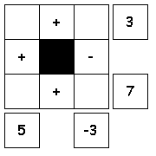

Use the numbers 1 through 4 to complete the equations.
Each number is only used once.
Each row is a math equation. Each column is a math equation.
Remember that multiplication and division are performed before addition and subtraction.

2 to the right and 2 forward
Try to fill in the missing numbers in the puzzle below.
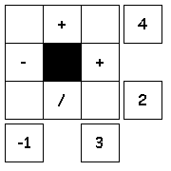

Use the numbers 1 through 4 to complete the equations.
Each number is only used once.
Each row is a math equation. Each column is a math equation.
Remember that multiplication and division are performed before addition and subtraction.

2 by 2 Solution

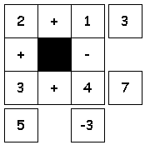

2 to the right and 2 forward Solution
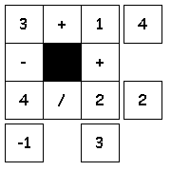

Created with Puzzlemaker at DiscoveryEducation.com

3 on 3
Try to fill in the missing numbers in the puzzle below.
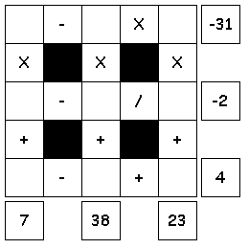

Use the numbers 1 through 9 to complete the equations.
Each number is only used once.
Each row is a math equation. Each column is a math equation.
Remember that multiplication and division are performed before addition and subtraction.

Three by Three
Try to fill in the missing numbers in the puzzle below.
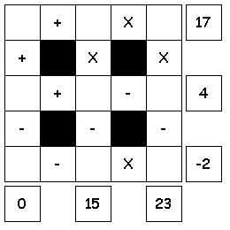

Use the numbers 1 through 9 to complete the equations.
Each number is only used once.
Each row is a math equation. Each column is a math equation.
Remember that multiplication and division are performed before addition and subtraction.

3 on 3 Solution

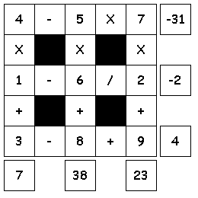

Three by Three Solution

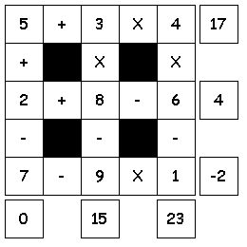

Created with Puzzlemaker at DiscoveryEducation.com

Block Party
Try to fill in the missing numbers in the puzzle below.
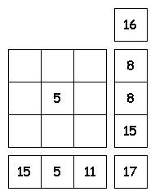

The missing numbers are integers between 0 and 9.
The numbers in each row add up to totals to the right.
The numbers in each column add up to the totals along the bottom.
The diagonal lines also add up the totals to the right.

Blockhead
Try to fill in the missing numbers in the puzzle below.
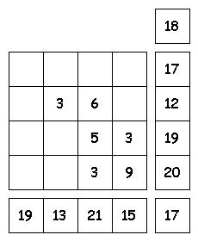

The missing numbers are integers between 0 and 9.
The numbers in each row add up to totals to the right. The numbers in each column add up to the totals along the bottom.
The diagonal lines also add up the totals to the right.

Diagonal, Horizontal, and Vertical

Try to fill in the missing numbers in the puzzle below.
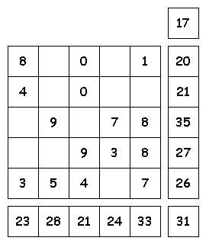

The missing numbers are integers between 0 and 9.
The numbers in each row add up to totals to the right.
The numbers in each column add up to the totals along the bottom.
The diagonal lines also add up the totals to the right.

Block Party Solution
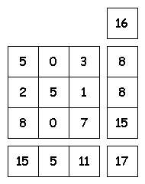

Blockhead Solution

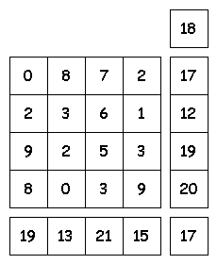

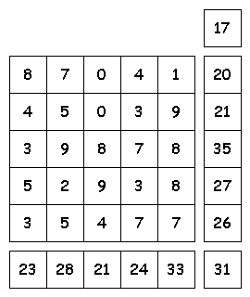
Diagonal, Horizontal, and Vertical Solution

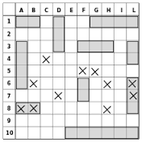

Battleship Moves Recording Sheet
Quadrant Signs:
Hits | Misses

Battleship Directions:

Objectives: The main objective is to familiarize students with the X-Y coordinate plane grid, which is used on the GED Mathematics test, and to introduce the students to the concept of ordered pairs.

Level/Subject: GED Mathematics/Algebra; X-Y coordinate grid, ordered pairs

Materials: Grid paper, pen or pencil, recording sheet

Directions:
- Keep the plots secret from others.
- A single quadrant is used per card and they follow the same standard pattern as is used for plotting ordered pairs and solving linear equations.
- In pairs sit face to face with graph cards so that the other player is not able to see where the points are.
- Once the players are facing each other, take turns calling out ordered pairs to each other.
- Each time an ordered pair is called by a player, it should be recorded on that player’s Battleship Moves Recording Sheet so they will not call out the same ordered pair again.
- If an order pair is called and is plotted on the opposing person’s grid, this should be marked as a “hit.” The first person to get five hits on the other person’s grid is the winner.
- Feel free to make explosion sounds when a plotted ordered pair is hit.

Practice for a X and Y Journey  Battleship  A Coordination Game |  | Practice for a X and Y Journey  Battleship  A Coordination Game
Practice for a X and Y Journey  Battleship  A Coordination Game |  | Practice for a X and Y Journey  Battleship  A Coordination Game
Practice for a X and Y Journey  Battleship  A Coordination Game |  | Practice for a X and Y Journey  Battleship  A Coordination Game
A=25  C=75  x= -, y= +  B=50  C  x  A  B |  | B  x= -, y= +  x  C  A  B=50  C=75  A=25
x= -, y= +  B  x  C  A  B=50  C=75  A=25 |  | A  B  x= -, y= +  x  A=25  C=75  B=50  C
B  x= -, y= +  A  x  C  B=50  C=75  A=25 |  | B  x= -, y= +  x  C  A  B=50  C=75  A=25
y  B=50  A  x= +, y= -  B  C  y  A=25  C=75 |  | y  y  B=50  A  B  x= +, y= -  C  C=75  A=25  A
y  B=50  C=75  A=25  B  x= +, y= -  A  C |  | B=50  C=75  A=25  B  x= +, y= -  C  A  y  A
x= +, y= -  B  C  B=50  C=75  A=25  A |  | A  C  B  x= +, y= -  B=50  C=75  A=25
B=50  x= +, y= +  A=25  B  C=75  C  A |  | B=50  x= +, y= +  C  C=75  B  A=25  A  A
B=50  x= +, y= +  C=75  C  A=25  B  A  C |  | B=50  B  C=75  x= +, y= +  C  A=25  A
B=50  C  C=75  B  x= +, y= +  A=25  A  C |  | B=50  C  C=75  B  x= +, y= +  A=25  A  C
A=25  C=75  B=50  C  A  x  y  x= -, y= -  B |  | B  y  x= -, y= -  x  C  A  B=50  C=75  A=25
y  B  x= -, y= -  x  C  A  B=50  C=75  A=25 |  | B  B=50  C=75  A=25  x  C  y  x= -, y= -  A
A  B  x  y  x= -, y= -  C  B=50  C=75  A=25 |  | B  C  x  y  x= -, y= -  A  B=50  C=75  A=25

Games of Fifteen
A game for two players – choose a version to play
The object of the game is to be the first player to create a line of 3 cards that add up to 15. The line can be vertical, horizontal or diagonal. The line can be made up of cards place by both players or only one taking turns.
Version 1: Place the number cards face down beside the board. Players take turns to pick a card and place it in a square.
Version 2: Place the number cards face up beside the board. Players take turns to choose a card and place it in a square.

15 Advanced one player game
Using the numbers/digits 1, 2, 3, 4, 5, 6, 7, 8, and 9, place the numbers within the proper squares so that each of the rows; vertical, horizontal, and diagonal adding up to 15 in each direction. Use each number only once.

Games of Fifteen
A game for two players – choose a version to play
The object of the game is to be the first player to create a line of 3 cards that add up to 15. The line can be vertical, horizontal or diagonal. The line can be made up of cards place by both players or only one taking turns.
Version 1: Place the number cards face down beside the board. Players take turns to pick a card and place it in a square.
Version 2: Place the number cards face up beside the board. Players take turns to choose a card and place it in a square.
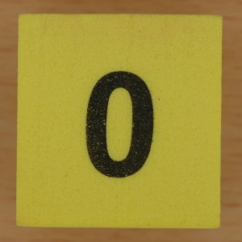 | 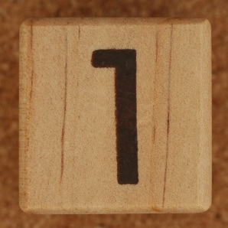 | 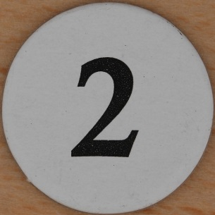 | 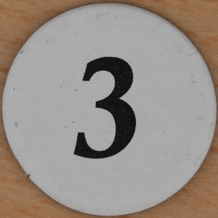
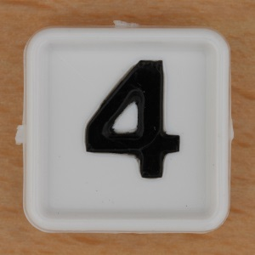 | 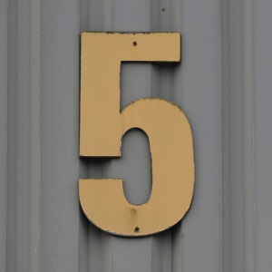 | 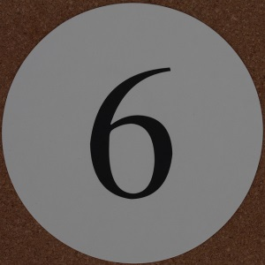 | 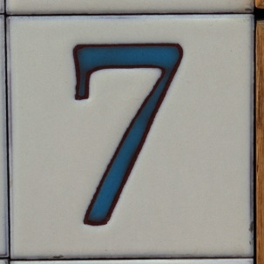
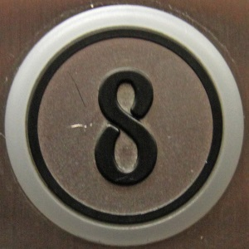 | 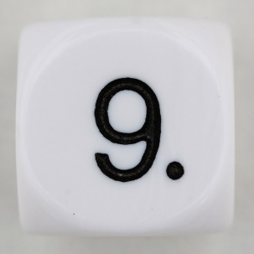 |  | 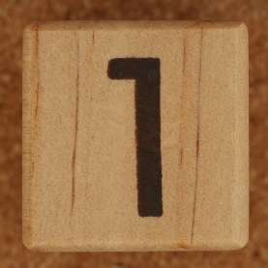
 | 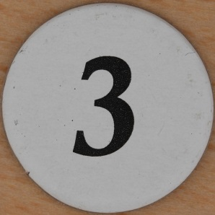 | 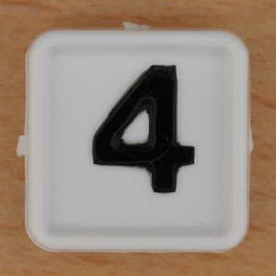 | 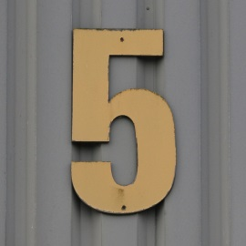

15 Advanced one player game
Using the numbers/digits 1, 2, 3, 4, 5, 6, 7, 8, and 9, place the numbers within the proper squares so that each of the rows; vertical, horizontal, and diagonal adding up to 15 in each direction. Use each number only once.

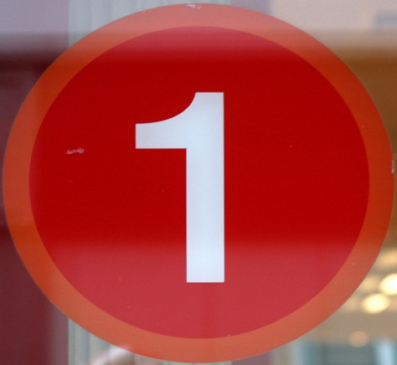 | 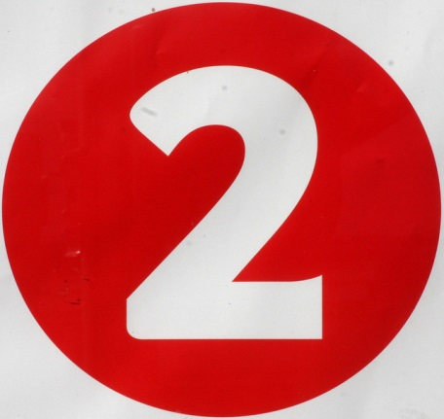 | 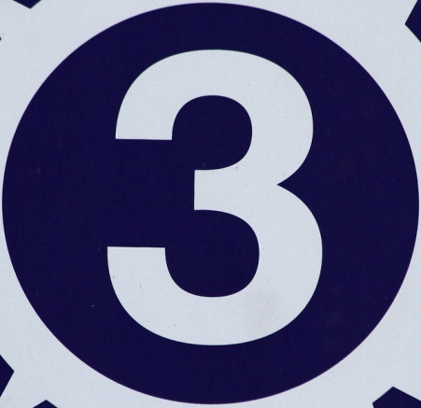
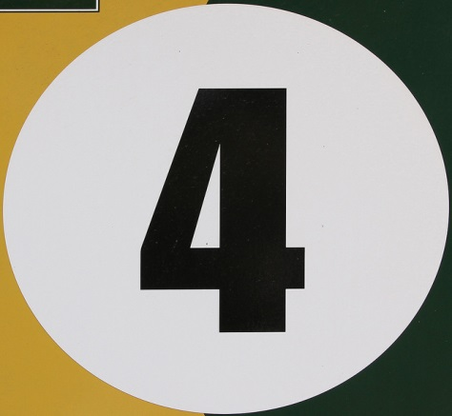 | 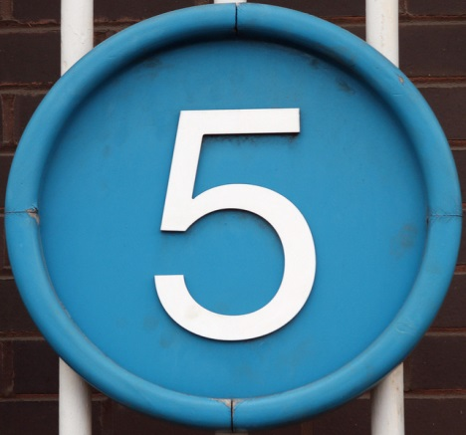 | 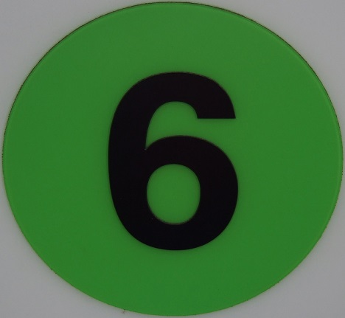
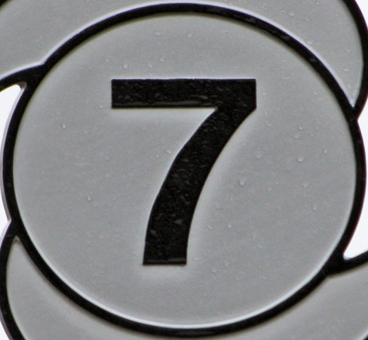 | 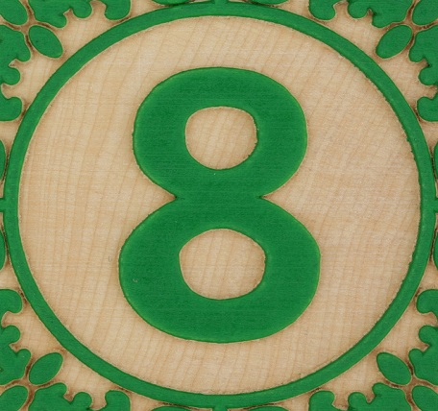 | 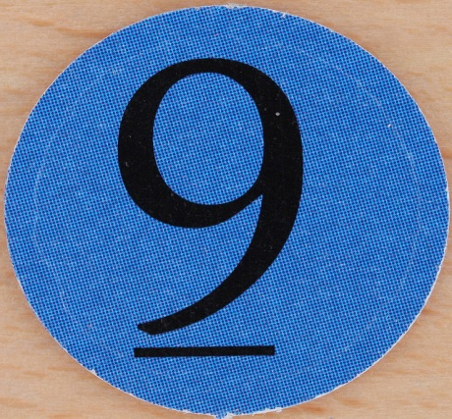

Fraction Flip It A fractions game for multiplying fractions.....
Skills: Multiplying and or Dividing Fractions
Number of Players: 2
What You Need: Deck of playing cards, Fraction Flip It game sheet for each player, paper and pencil for each player, directions
Preparation: Remove the face cards from the deck. Print out a copy of the game sheet for each player.
Object of Game: To see who can earn the most points by correctly multiplying fractions.
How to Play:
- Shuffle the cards and stack them face down.
- Player 1 draws the top card and places it on the game sheet.
- Players continue drawing cards and placing them until they have filled all four spaces.....
Take a look at an example below....
Each player takes turns drawing one card at a time. After each card they draw, they place the card in one of the four empty rectangles on their game sheet. Each player continues drawing in turn until all players have four cards placed in all four spaces on their game sheets.
In this example player 1 has placed his cards on his game sheet in the spots pictured below. Player 1 will then write their multiplication statement on their paper and solve it. The correct answer that player 1 should write down on his paper for this round would be 8/15 (eight-fifteenths).

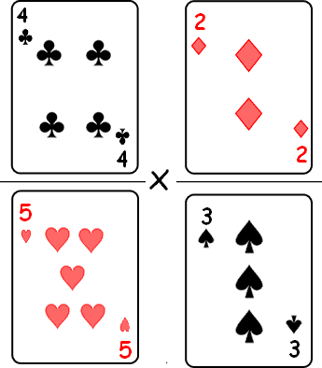
Each player multiplies their two fractions on their game sheets and simplifies the fraction if possible.

Fraction Flip It – Working Table
4 Card Draws | Work | Answer
#1
#2
#3
#4
#5

Fractions Flip The Cards

GEOBINGO Board
FREE SQUARE

GEOBINGO is a geometry review game for students who have covered the following 24 geometry terms:

• acute angle | • parallelogram
• circle | • pentagon
• equilateral triangle | • plane
• hexagon | • point
• intersecting lines | • quadrilateral
• scalene triangle | • ray
• line | • rectangle
• line segment | • rhombus
• parallel lines | • right angle
• perpendicular lines | • right triangle
• obtuse angle | • square
• octagon | • trapezoid

GEOBINGO is played with a twenty-five squares board and word cards, similar to BINGO. Each geometry term may be found represented by a picture on the board. You may also want your students to design their own cards with a computer or markers. A blank board is provided for that purpose.
Game directions: 3 players - (one calls out and the other two play the board) Place the geometry word calling cards face-down on a flat surface. Players may choose one person to be the caller and take turns by game. When a term is called out, the first player to identify it on their board and call out the word “geo” will receive the card to put over the diagram space.
As in traditional BINGO, GEOBINGO may be won by covering parts of the board:
- Three across diagonally, horizontally or vertically
- Four corners
- Cover-all
- Use your own pattern!
The GEOBINGO cards or the calling cards may also be used as individual flash cards to review and reinforce geometry vocabulary.

GEOBINGO Call Words
acute angle | parallelogram | circle | pentagon | equilateral triangle
hexagon | plane | intersecting lines | scalene triangle | quadrilateral
scalene triangle | ray | FREE SQUARE | line | rectangle
line segment | rhombus | parallel lines | right angle | perpendicular lines
obtuse angle | square | octagon | trapezoid | point

3DINGO Call Words
cylinder | cube | triangular pyramid | cone | rectangular prism
sphere | triangular  prism | octahedron | hexagonal prism | tetrahedron
dodecahedron | octagonal pyramid | FREE SQUARE | octagonal  prism | pentagonal pyramid
pentagonal prism | hexagonal pyramid | square pyramid | square prism | rectangular pyramid
dodecagonal prism | dodecahedron prism | hemisphere | frustum | icosahedron

3DINGO
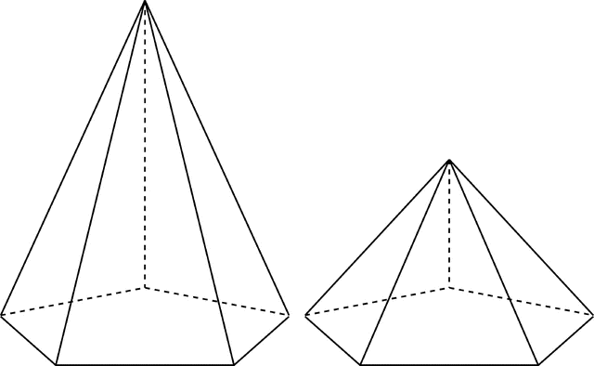 |  | 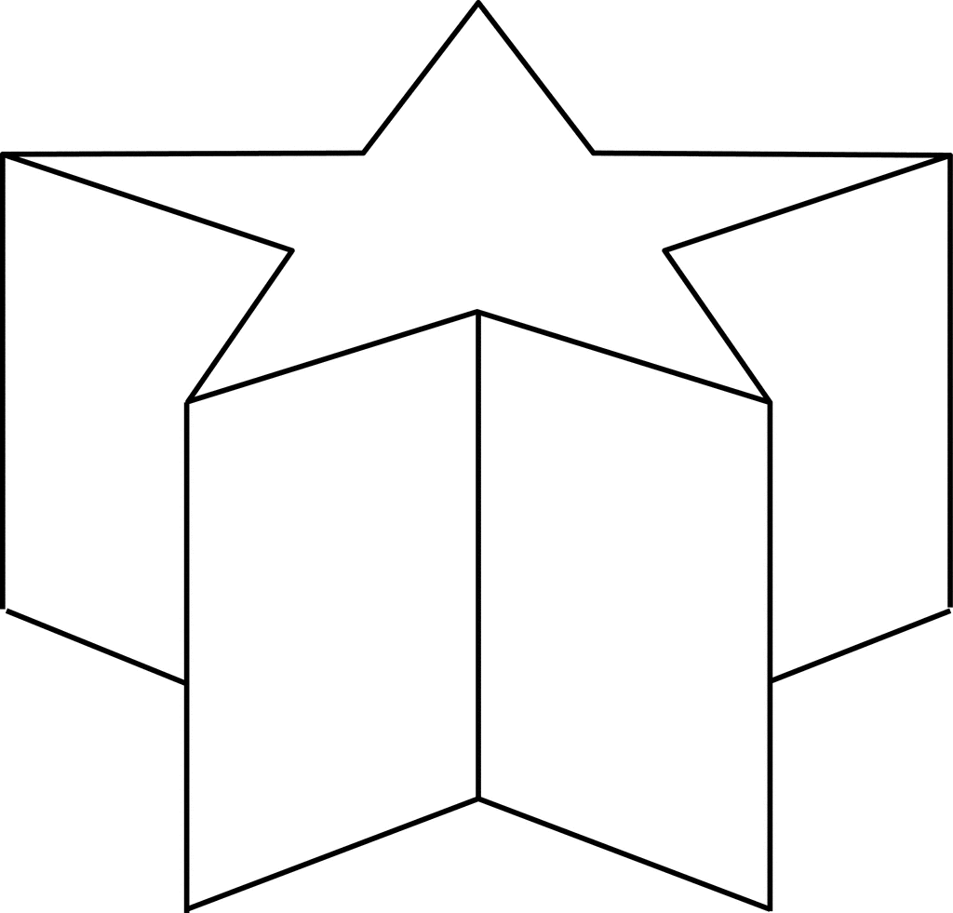 | 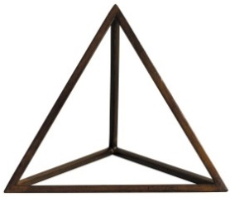 | 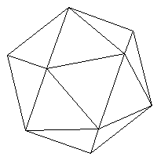
 |  |  |  | 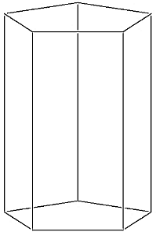
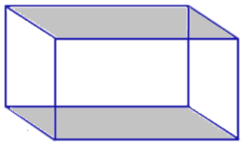 | 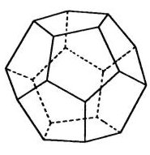 | FREE SQUARE |  | 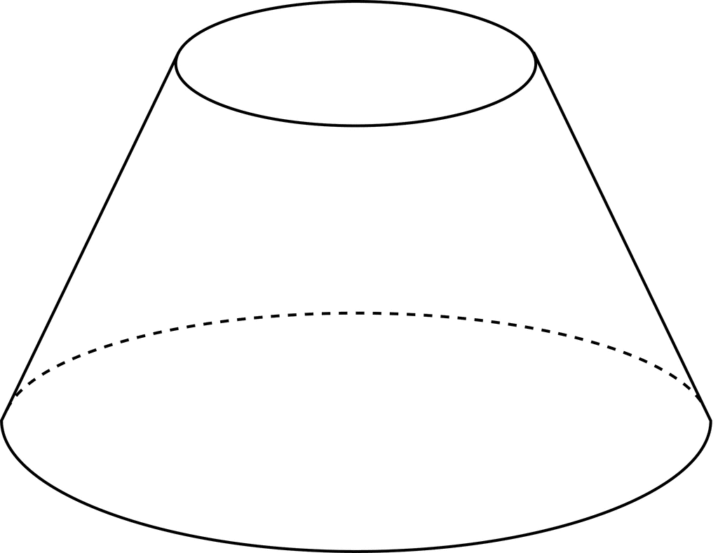
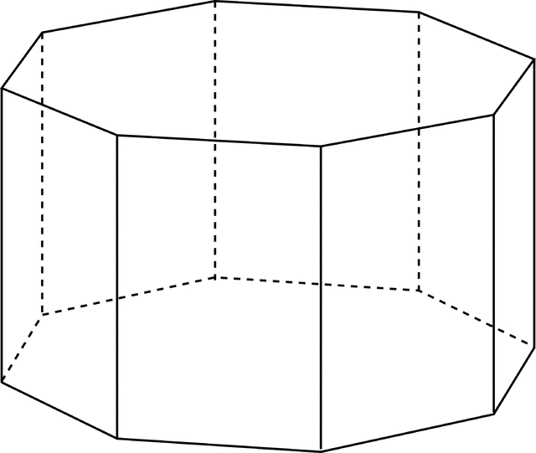 | 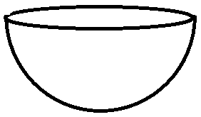  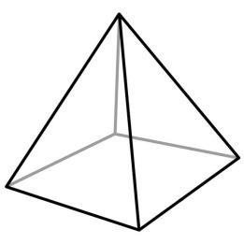 |  |  | 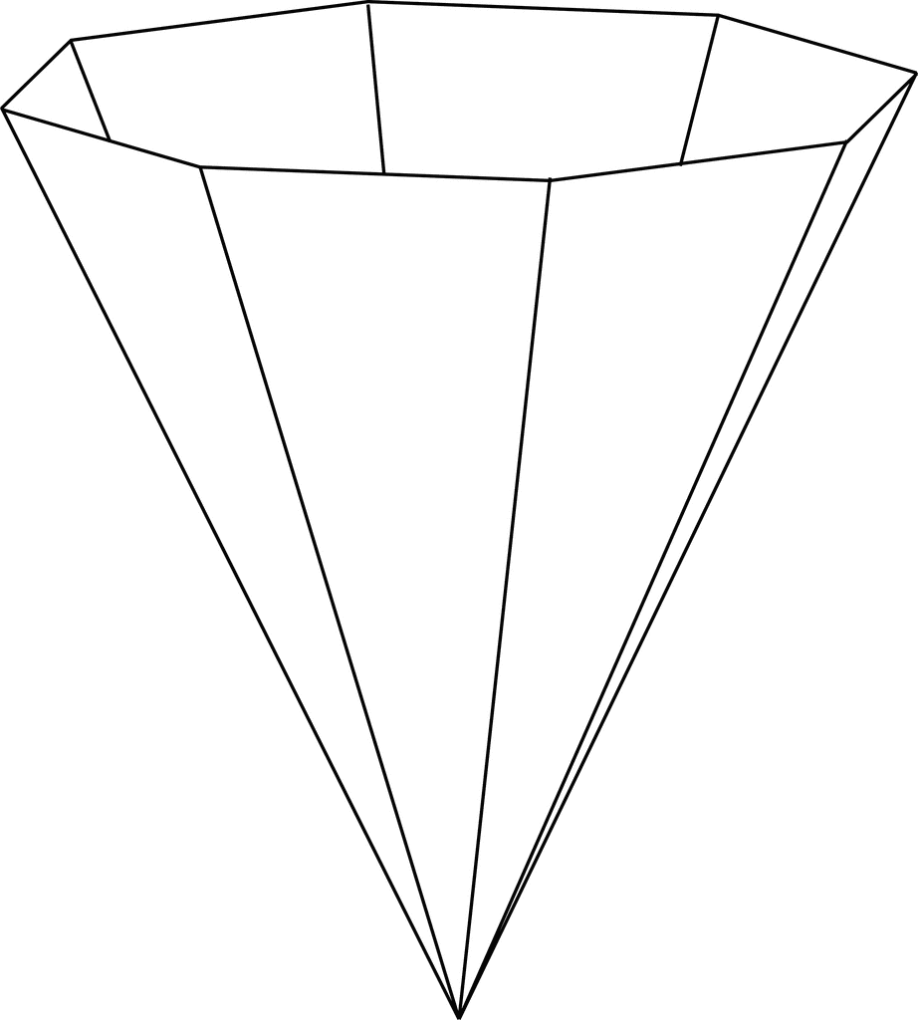
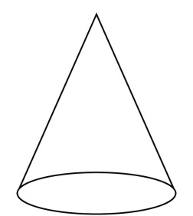 | 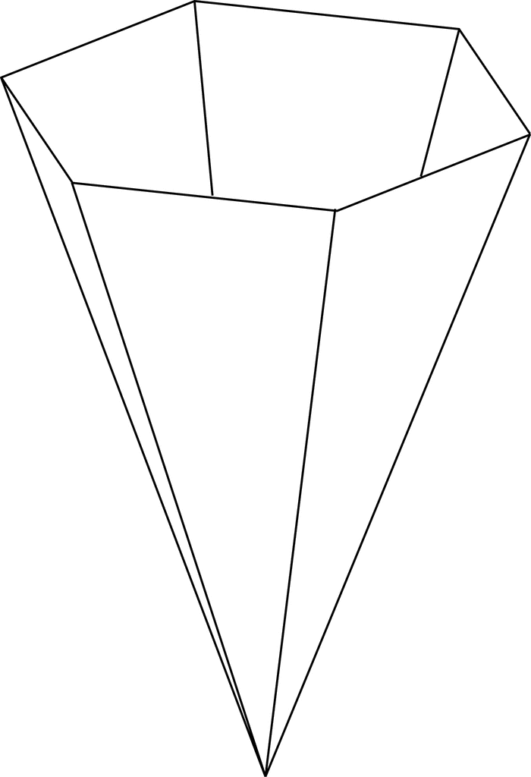 | 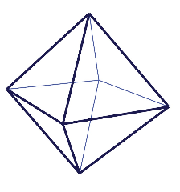 | 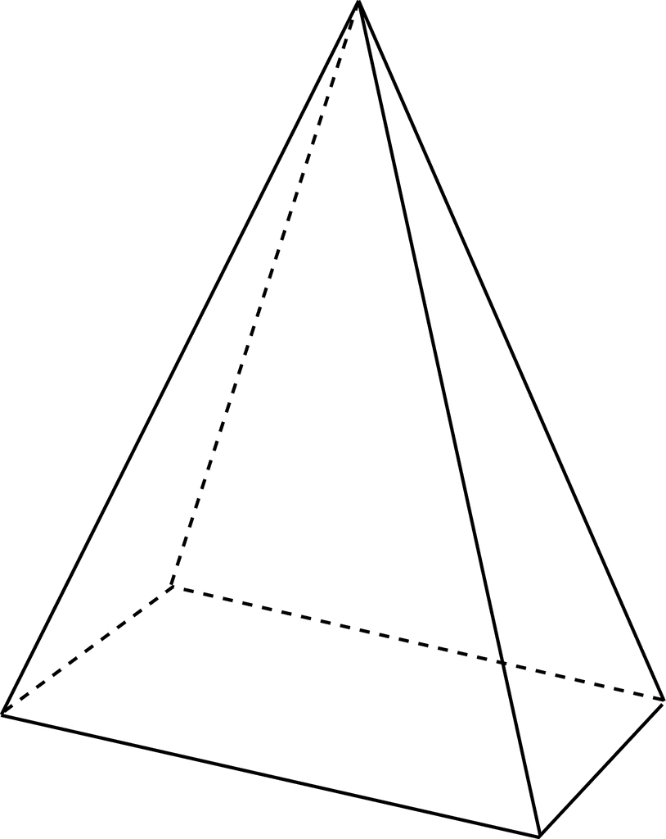 | 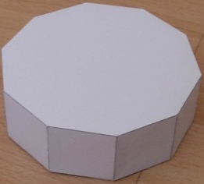

3DINGO is a geometry review game for students who have covered the following 24 geometry terms:

• cone | • octagonal pyramid
• cube | • octahedron
• cylinder | • pentagonal prism
• dodecagonal prism | • pentagonal pyramid
• dodecahedron | • rectangular prism
• dodecahedron prism | • rectangular pyramid
• frustum | • sphere
• hemisphere | • square prism
• hexagonal prism | • square pyramid
• hexagonal pyramid | • tetrahedron
• icosahedron | • triangular prism
• octagonal prism | • triangular pyramid

3DINGO is played with a twenty-five squares board and word cards, similar to BINGO. Each geometry term may be found represented by a picture on the board. You may also want your students to design their own cards with a computer or markers. A blank board is provided for that purpose.
Game directions: 3 players - (one calls out and the other two play the board) Place the geometry word calling cards face-down on a flat surface. Players may choose one person to be the caller and take turns by game. When a term is called out, the first player to identify it on their board and call out the word “geo” will receive the card to put over the diagram space.
As in traditional BINGO, 3DINGO may be won by covering parts of the board:
- Three across diagonally, horizontally or vertically
- Four corners
- Cover-all
- Use your own pattern!
The 3DINGO cards or the calling cards may also be used as individual flash cards to review and reinforce geometry vocabulary.

Multiplication Dominoes
5
30
6

30
5
6

Multiplication Dominoes
Directions:
1. Mix up fraction dominos face down, have each player pick eight.
2. Keep the dominoes face down.
3. Select two or four depending on what you want to solve.
4. Turn the dominoes face up and place them in order one-by-one in the squares provided in a clockwise fashion.
5. Solve for each domino fraction.
6. Do not write in the squares provided for the answer, instead select cutout number squares to interpret your answer.
7. Your competition will check the answer and challenge it if needed, working out the result on paper or on a calculator.
8. 5 points for one correct answer and ten points for two.
9. Keep track of points and more below.
Player 1 |  | Player 2
Solving 1 fraction 5 points | Solving 2 fraction 10 points | Solving 1 fraction 5 points | Solving 2 fraction 10 points

How to Play War (Card Game)

“Points of War” – Decimal War and “War and Pieces” – Fraction War
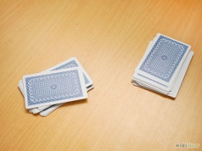
Has Lady Luck always shined on you? Rather than taking a chance in the gambling rooms of Las Vegas, why don't you try playing War instead? War is a game of chance that is played around the world. Save yourself some money and settle down with a friend or two and wage War.

Part 1 of 2: Setting up War
1. Know the object of the game. The goal of the game is to eventually win all of the cards. War is generally played between two people, but up to four people can play. The ranking for cards in War is from highest to lowest.
2. Shuffle the cards. Try to mix them up as much as possible.
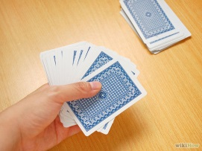
3. Deal the cards. Deal back and forth between you and your opponent until the two of you have the same number of cards; make sure all cards have been dispersed. Neither player should look at his or her cards.

Part 2 of 2: Playing War
1. Place the cards face-down on the table. Players are not allowed to look at their cards. Your opponent should not be able to see your cards either. You can also hold them fanned out away from you.
2. Count to three and then flip a card. Each player must count down and flip a card at the same time. You should only flip the top card of your stack of cards.
3. Compare your cards to see which is higher. The player with the higher card wins (the higher fraction or decimal) the round and collects both cards to add to their hand.
4. Go to 'War' when the cards you flip are the same card. For example, you both flip your cards and each of you flips over a '.25 '. Now is the time to go to war. To go to war, each player must place three more cards face-down on the table. Flip over a fourth card as you would flip a card when not at 'War'. Whoever has the higher fourth card is the person who takes all 10 cards from the round. If a player doesn't have enough cards to play the war, the player must turn his/her last card face-up. This will be the card used to play the war.
Points of War  1.41 |  | Points of War  0.41
5. Play until one person wins all the cards in the deck. This might take a while, since War is a game of chance.

3
5

3
2

7
9

3
7

War & Pieces |  | War & Pieces

Numeracy Board Game Pieces
Move ahead 2 spaces
Start

Move ahead 3 spaces
Finish

Go back 3 spaces
Go back 2 spaces

Move ahead 1 space
Go back 1 space

fraction
difference

average
sum

constant
product
rate
compounded

interest
principal

mean
mode

compound interest
simple interest

finite
infinite

apex
angle

midpoint
fixed

range
remainder

ratio
variable

reciprocal
term

Angle - Two rays sharing a common endpoint. Angles are typically measured in degrees or radians. |  | Apex - The vertex at the tip of a cone or pyramid. |  | Average - This almost always refers to the arithmetic mean. In general, however, the average could be any single number that represents the center of a set of values.
Compound Interest - A method of computing interest in which interest is computed from the up-to-date balance. That is, interest is earned on the interest and not just on original balance. |  | Constant - As a noun, a term or expression with no variables. Also, a term or expression for which any variables cancel out. Example, –42 is a constant. So is 3x + 5 – 3x, which simplifies to just 5. |  | Difference - The result of subtracting two numbers or expressions. For example, the difference between 7 and 12 is 12 – 7, which equals 5.
Finite - Describes a set which does not have an infinite number of elements. That is, a set which can have its elements counted using natural numbers. |  | Fixed - Constant. Not changing or moving. |  | Fraction - A ratio of numbers or variables. Fractions may not have denominator 0.
Infinite - Describes a set which is not finite. Formally, a set is infinite if it can be placed in one-to-one correspondence with a proper subset of itself. |  | Interest - The process by which an amount of money increases over time. With interest, a fixed percentage of the money is added at regular time intervals. |  | Mean - Another word for average. Mean almost always refers to arithmetic mean.
Midpoint - The point halfway between two given points. |  | Mode - The number that occurs the most often in a list. Example: 5 is the mode of 2, 3, 3, 4, 5, 5, 5 |  | Principal - In finance, the original amount of money invested, deposited, or loaned.
Product - The result of multiplying a set of numbers or expressions. |  | Range - The set of y-values of a function or relation. More generally, the range is the set of values assumed by a function or relation over all permitted values of the independent variable(s). |  | Ratio - The result of dividing one number or expression by another. Sometimes a ratio is written as a proportion, such as 3:2 (three to two).
Reciprocal - Multiplicative Inverse of a Number: The reciprocal of x is. In other words, a reciprocal is a fraction flipped upside down. Multiplicative inverse means the same thing as reciprocal. |  | Remainder - The part left over after long division. |  | Simple Interest - A method of computing interest. Interest is computed from the (original) principal alone no matter how much money has accrued so far.
Sum - The result of adding a set of numbers or algebraic expressions. |  | Term - Parts of an expression or series separated by + or – signs, or the parts of a sequence separated by commas. |  | Variable - A quantity that can change or that may take on different values. Variable also refers to a letter or symbol representing such a quantity.
Angle - Two rays sharing a common endpoint. Angles are typically measured in degrees or radians. |  | Apex - The vertex at the tip of a cone or pyramid. |  | Average - This almost always refers to the arithmetic mean. In general, however, the average could be any single number that represents the center of a set of values.
Compound Interest - A method of computing interest in which interest is computed from the up-to-date balance. That is, interest is earned on the interest and not just on original balance. |  | Constant - As a noun, a term or expression with no variables. Also, a term or expression for which any variables cancel out. Example, –42 is a constant. So is 3x + 5 – 3x, which simplifies to just 5. |  | Difference - The result of subtracting two numbers or expressions. For example, the difference between 7 and 12 is 12 – 7, which equals 5.

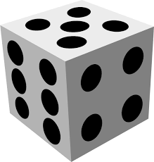

Numeracy Board Game Directions
- Group members lay game pieces along in a path.
- Group members decide where the direction and word pieces go in the path.
- Setup all the direction and six word pieces along in a path.
- Players select a colored walker.
- Roll the die and the player with the highest score goes first.
- Roll the die; move you’re your colored walker. Each time a player lands on a word card, write a complete sentence using the math word in the sentence.
- You can write the sentence down on the index cards provided.
- Other players can check or challenge the sentence accuracy by looking at the definition behind the word card.
- If a word is checked or challenged, no matter the result it must be replaced within the path with a new word card.
- The one who gets to the end first wins!
- Variations on this game can include answering with the definition or giving real-life examples instead of a complete sentence.

Helpful math definition website
http://www.mathwords.com/

Definitions:
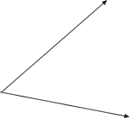
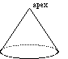
Angle Two rays sharing a common endpoint. Angles are typically measured in degrees or radians.
Apex The vertex at the tip of a cone or pyramid.
Average This almost always refers to the arithmetic mean. In general, however, the average could be any single number that represents the center of a set of values.
Compound Interest A method of computing interest in which interest is computed from the up-to-date balance. That is, interest is earned on the interest and not just on original balance.
Constant As a noun, a term or expression with no variables. Also, a term or expression for which any variables cancel out. For example, –42 is a constant. So is 3x + 5 – 3x, which simplifies to just 5. As an adjective, constant means the same as fixed. That is, not changing or moving.
Difference The result of subtracting two numbers or expressions. For example, the difference between 7 and 12 is 12 – 7, which equals 5.
Finite Describes a set which does not have an infinite number of elements. That is, a set which can have its elements counted using natural numbers. Formally, a set is finite if its cardinality is a natural number.
Fixed Constant. Not changing or moving.
Fraction A ratio of numbers or variables. Fractions may not have denominator 0.
Infinite Describes a set which is not finite. Formally, a set is infinite if it can be placed in one-to-one correspondence with a proper subset of itself.
Interest The process by which an amount of money increases over time. With interest, a fixed percentage of the money is added at regular time intervals. Types of interest: simple interest, compound interest, continuously compounded interest
Mean Another word for average. Mean almost always refers to arithmetic mean. In certain contexts, however, it could refer to the geometric mean,harmonic mean, or root mean square.
Midpoint - The point halfway between two given points.

Mode - The number that occurs the most often in a list. Example: 5 is the mode of 2, 3, 3, 4, 5, 5, 5
Principal - In finance, the original amount of money invested, deposited, or loaned.
Product - The result of multiplying a set of numbers or expressions.
Range - The set of y-values of a function or relation. More generally, the range is the set of values assumed by a function or relation over all permitted values of the independent variable(s).
Ratio - The result of dividing one number or expression by another. Sometimes a ratio is written as a proportion, such as 3:2 (three to two). More often, though, ratios are simplified according to the standard rules for simplifying fractions or rational expressions. Note: The word "rational" indicates that a ratio (in the second sense) is involved. The word rate also indicates a ratio is involved, as ininstantaneous rate of change or average rate of change.
Reciprocal - Multiplicative Inverse of a Number: The reciprocal of x is . In other words, a reciprocal is a fraction flipped upside down. Multiplicative inverse means the same thing as reciprocal. For example, the multiplicative inverse (reciprocal) of 12 is and the multiplicative inverse (reciprocal) of is .
Note: The product of a number and its multiplicative inverse is 1.
Remainder - The part left over after long division.
Simple Interest - A method of computing interest. Interest is computed from the (original) principal alone no matter how much money has accrued so far.
Formula: A = P(1 + nr)
Sum - The result of adding a set of numbers or algebraic expressions.
Term - Parts of an expression or series separated by + or – signs, or the parts of a sequence separated by commas.
Variable - A quantity that can change or that may take on different values. Variable also refers to a letter or symbol representing such a quantity.

11-11-11
Pairs and Triplets – Addition to 11

A game for 2 players

Players take turns to cross off an adjoining 2 or 3 numbers that add to 11. The 2 or 3 numbers must be in squares that are in a straight line horizontally or vertically, but not diagonally. Once a number has been crossed off, it cannot be used again. The last player who is able to cross off 2 or 3 numbers that total 11, is the winner for that game.

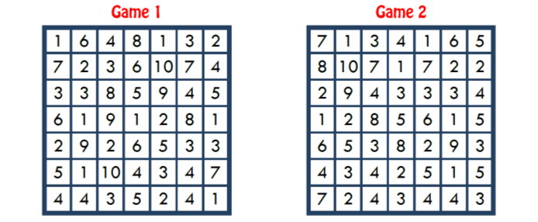
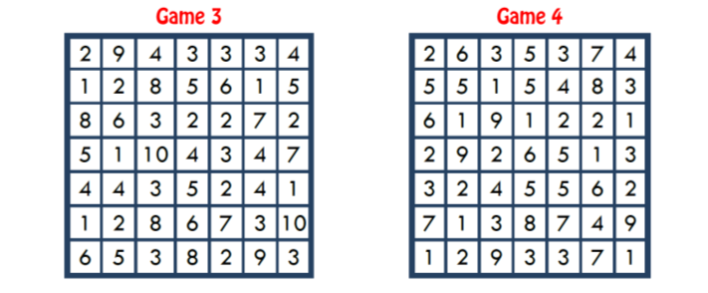

Pairs – Subtraction to 11

A game for 2 players

Players take turns to cross off a pair of adjoining numbers with a difference of 11, e.g. 15 and 4 (15 - 4=11). The pair of numbers must be in squares that are joined by a side, not joined by corners. Once a number has been crossed off, it cannot be used again. The last player who is able to cross off a pair is the winner for that game.

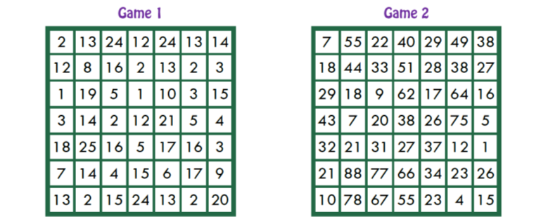
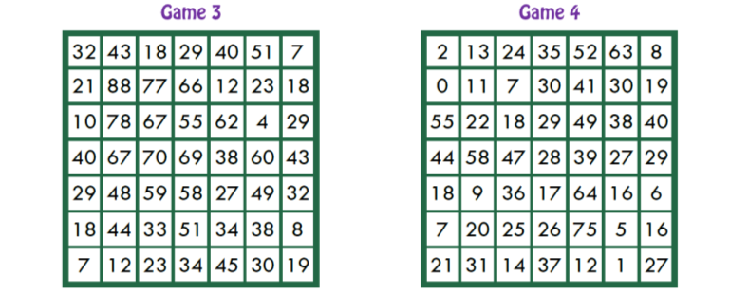

Celebrate 11-11-11 w/ Equations

To celebrate this special date, can you make 11, three times by putting the given digits into the equations below?

- Fill in the boxes with these digits to make a true equation – 2, 4, 5, 6.

- Fill in the boxes with these digits to make a true equation – 3, 8, 8, 9.

- Fill in the boxes with these digits to make a true equation – 3, 4, 6, 8.

11-11-11 scoring table
Player 1 | Player 2

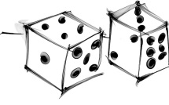
Setting the Basic Rules for Math and Dice
Before you start playing, you should agree with your partner on some of the basic Math and Dice rules. Here are the rules you need to agree on.
- How to get the Target Number. Will you add the Target Dice or multiply them together?
- What operations you're allowed to use. All games use addition, subtraction, and multiplication. Will you allow division? Will you allow exponents?
- Can you use pencil and scratch paper to help you play? Can you use a calculator (not recommended)?
- What is the penalty for not being able to state a correct equation to back up your winning answer? Should the other player get the point? Should it be a do over? Should each player get one free missed answer per game before the penalty kicks in?
- What happens if two people call out the same answer at the same time? We recommend making this a do-over.
How to Play Math and Dice
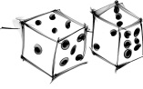
With basic Math and Dice, two players compete against each other. (The game can also be played by three or more players, or by teams of players, with a slight adjustment to the scoring rules.) Players roll the dice as described below: winning a roll of the dice earns a player one point. Play continues until one player has won four points, or the best of seven points.
Playing a Point http://www.bgfl.org/bgfl/custom/resources_ftp/client_ftp/ks1/maths/dice/index.htm
- To start, one player rolls the four 6-sided dice w/ up 12 counts. Together, players combine the two numbers rolled to establish a Target Number. If you want to play the easier version of the game, add the four numbers together, if you want to play the more challenging version, multiply the four numbers together.
- After the Target Number has been established, the second player rolls the three 6-sided Scoring dice. As soon as these dice have been rolled, they are in play for both players.
- Using each of the numbers on the dice once and only once, and combining them using any combination of addition, subtraction, multiplication, division, and/or powers, the two players work to calculate a math expression that comes as close as possible to the target. When using powers, you must use one or more of the scoring numbers to get your exponent.
- Once a player has calculated a number she's satisfied with, she calls it out. The other player then tries to find a different math expression, using the same Scoring Numbers that gets closer to the target than this. Players go back and forth until one player either hits the target exactly or the other player cannot find a closer number.
- When players agree that no one can find a better answer, the player with the closest answer must then state the equation that he used to get his result. If the equation is correct, that player gets the point. If the equation is incorrect or the player can't remember the equation, the other player gets the point.
- As stated above, players then repeat this process, rolling Target and Scoring Dice again. First player to reach 4 points wins the game. That's it!

Math and Dice recording table
12 Dice Roll Target Number | 6 dice Player one expression | 6 dice Player two expression

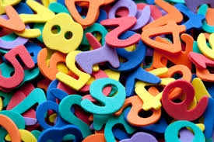

Sweet Sixteen

Can you arrange the numbers 2 to 9 in these boxes, so that each row and column of three connected squares adds up to 16?

Sweet Sixteen Board Game Number cutouts 2 - 9

If your total bill for a raincoat is $103.68, including $7.86 in tax, what was the actual purchase price of the coat? | My income is a combination of my $32,000 yearly salary and $6.500 profits from my investments.
If you pay $20.00 for a $17.58 purchase, how much change will you receive? | If the total number of  adult students is 1,860, what is  the average number of  students that  will be in each of 65 classes?
How many $256 payments will it take to pay off a total of $2,304? | How many times faster is a car going 45 miles per hour than a man walking 2.5 miles per hour?
The Jones spend $360 per month on daycare. Their niece will babysit for $1,830 semiannually. Which is a less expensive choice? | On average, 24 cars pass through  the toll plaza a minute.  How many pass through  in an hour?
Each of 6 employees contribute $5 for a gift certificate. | Because of the sale, I paid  $12 less than the original  price of $40.
Jack and 4 friends agreed to split  the $2,000 prize if they won. | What is the sum of 84 and  the next odd number?
How far can I drive at 55 miles  per hour in 6 1∕2 hours? | Your yearly insurance premium  of $376 can be paid quarterly.
What will it cost for each  bagel at $3.85 per dozen? | Jose doubled his $18,000 salary  when he took a new job.
How many 41∕2 inch pieces can  be cut from a board 1 yard long? | The stock was listed at 15  on Monday and then dropped  7/8 on Tuesday.
How much more than $3,500  is a $4,275 down payment? | Marcie was happy about the 88₡  raise on her hourly wage of $8.75.
About 3∕4 of the $3,000 fans at a football game were cheering  for the home team. | If your total bill for a raincoat is $103.68, including $7.86 in tax,  what was the actual purchase  price of the coat?
If you pay $20.00 for a $17.58 purchase, how much change will you receive? | If the total number of  adult students is 1,860, what is  the average number of  students that  will be in each of 65 classes?
How many $256 payments will it take to pay off a total of $2,304? | How many times faster is a car  going 45 miles per hour than a man  walking 2.5 miles per hour?
The Jones spend $360 per month on daycare. Their niece will babysit for $1,830 semiannually. Which is a less expensive choice? | On average, 24 cars pass through  the toll plaza a minute.  How many pass through  in an hour?
How much more than $3,500  is a $4,275 down payment? | Marcie was happy about the 88₡  raise on her hourly wage of $8.75.
Jack and 4 friends agreed to split  the $2,000 prize if they won. | What is the sum of 84 and  the next odd number?
How far can I drive at 55 miles  per hour in 6 1∕2 hours? | Your yearly insurance premium  of $376 can be paid quarterly.
What will it cost for each  bagel at $3.85 per dozen? | Jose doubled his $18,000 salary  when he took a new job.
How many 41∕2 inch pieces can  be cut from a board 1 yard long? | The stock was listed at 15  on Monday and then dropped  7/8 on Tuesday.
How much more than $3,500  is a $4,275 down payment? | Marcie was happy about the 88₡  raise on her hourly wage of $8.75.
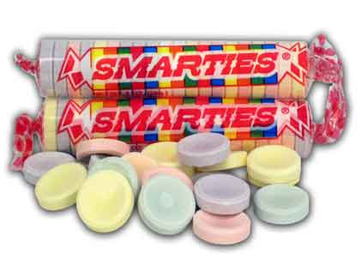 |  | 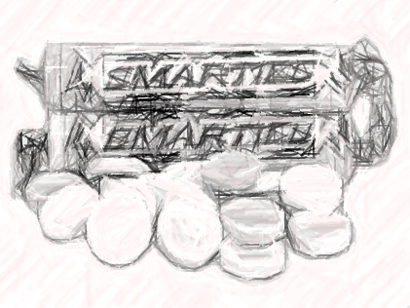
 |  | 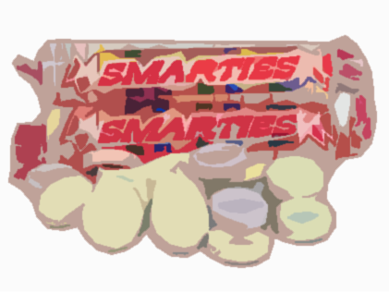
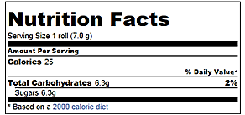  Before you open the pack  Count and determine what percent of your Smarties package are yellow?  How do you express that in a ratio?  Count how many candy pieces are in a single package.  What is the probability that you will first pull out a yellow Smartie out of your package?  Draw 6 Smarties out in a row  What is the probability of drawing a white Smartie out of these six? |  | Before you open the pack  Count and determine what percent of your Smarties package are yellow?  How do you express that in a ratio?  Count how many candy pieces are in a single package.  What is the probability that you will first pull out a yellow Smartie out of your package?  Draw 6 Smarties out in a row  What is the probability of drawing a white Smartie out of these six?
Before you open the pack  Count and determine what percent of your Smarties package are yellow?  How do you express that in a ratio?  Count how many candy pieces are in a single package.  What is the probability that you will first pull out a yellow Smartie out of your package?  Draw 6 Smarties out in a row  What is the probability of drawing a white Smartie out of these six? |  | Before you open the pack  Count and determine what percent of your Smarties package are yellow?  How do you express that in a ratio?  Count how many candy pieces are in a single package.  What is the probability that you will first pull out a yellow Smartie out of your package?  Draw 6 Smarties out in a row  What is the probability of drawing a white Smartie out of these six?
Before you open the pack  Count and determine what percent of your Smarties package are yellow?  How do you express that in a ratio?  Count how many candy pieces are in a single package.  What is the probability that you will first pull out a yellow Smartie out of your package?  Draw 6 Smarties out in a row  What is the probability of drawing a white Smartie out of these six? |  | Before you open the pack  Count and determine what percent of your Smarties package are yellow?  How do you express that in a ratio?  Count how many candy pieces are in a single package.  What is the probability that you will first pull out a yellow Smartie out of your package?  Draw 6 Smarties out in a row  What is the probability of drawing a white Smartie out of these six?

