Static to Dynamic: The Complete Math Experience

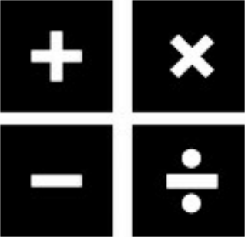

**Tactile, paper, and tech engaging activities preparing students for the everyday life math and the GED®, TASC, or HiSET. This workshop introduces examples in lesson planning for the math interactive classroom. Get rewarded with motivating lessons that actively engage. Well-planned, multi-sensory activities develop skills needed for math success. Realia, hardcopies and computer interaction create a harmoniously balanced instruction that meaningfully utilizes technology.**

Michael Matos

matosmichael2@gmail.com

Albany Park Community Center – Chicago, Illinois

COABE Conference 2015 in Denver, Colorado

Wednesday, 4/22 10:45am-12:00pm, L3 Mineral Hall D

**https://delicious.com/apccctc/**

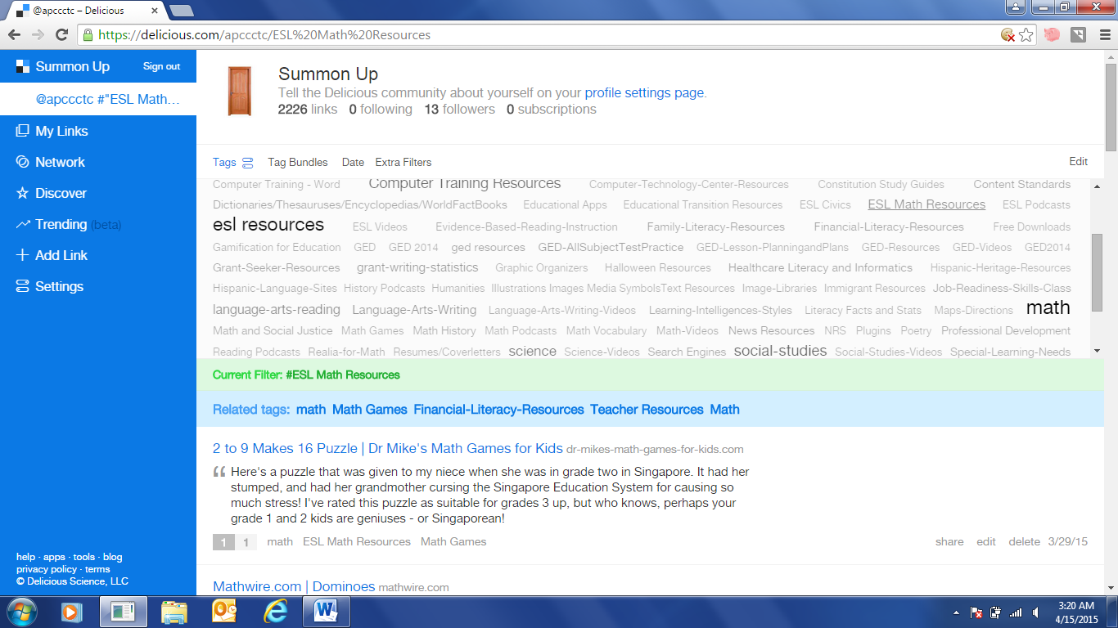

**Some Math Teaching Strategies**

Using manipulatives when teaching math is important: Manipulatives help learners visualize the numbers and remember as much as possible. You are trying to make numbers come to life for your learners. Base your instruction in your learners’ real world experience and have manipulatives on hand to show them what you’re talking about.

* Everyday Math Activities
* Math bag of tricks “Realia”
* Financial Literacy, Health Literacy, Social Studies, etc.
* Multiple Intelligence learning strengths

**Accelerated or individualized math**: a system of having students work at different levels individually in one classroom. They progress by scoring higher on assessments for each unit and moving at their own pace.

**Building vocabulary**:Use brief, random, and recurrent assessments to help students build basic subject-specific vocabulary and also gauge student retention of subject-specific vocabulary. Review mathematical vocabulary and concepts using [math games](http://suite101.com/article/four-math-games-for-elementary-school-students-a66265). ***Student developed glossaries*** can be used; where students keep track of key content and concept words and define them in a log or series of worksheets that they keep with their text to refer to.

**Design multi-sensory lessons**: that address various student learning styles, i.e., visual, auditory, tactile, and kinesthetic.

**Generate data from real life experiences**: involving all aspects of an adult’s life, including education, family, neighborhood, employment, and community, in teaching the child useful life and educational skills.

**Integrate educational technology**:tools, i.e., online tools, interactive Office documents, online math websites, and interactive computer games.

**Problem solving instruction**: explicit instruction in the steps to solving a mathematical or science problem including understanding the question, identifying relevant and irrelevant information, choosing a plan to solve the problem, solving it, and checking answers.

**Reinforcing math skills through games**: Using games to follow-up a lesson in order to reinforce learned skills and use the skills in another context.

**Student generated word problems:** Have students create word problems for a specific math skill. Through the construction of a problem the students learn what to look for when solving word problems they are assigned. Students learn to understand the setup of a mathematical situation.

**Tactile, tangible experiences in math:** Using three dimensional objects in math instruction such as geometrical shapes, coins, or blocks used to form various geometrical shapes. Integrate hands-on activities by using manipulatives, real life materials, and calculators. *Use visuals* whenever possible to reinforce auditory instruction, i.e., charts, graphs, manipulatives, diagrams, models, real objects.

**Using Graphic Organizers**: employing visual displays to organize information into things like trees, flowcharts, webs, etc. They help students to consolidate information into meaningful whole and they are used to improve comprehension of stories, organization of writing, and understanding of difficult concepts in word problems.

**KEY OPERATION WORDS**

**For Solving Word Problems**

|  |  |
| --- | --- |
| **ADDITION**  Add  All together  And  Both  Combined  How many in all  In All  Increased by  Increase  More  More than  Plus  Sum  Total | **SUBTRACTION**  Change (for money)  Decrease  Decrease by  Difference  Farther  How many more  How many less  How much left  Larger  Left  Less than  Nearer  Reduce  Remain/remaining  Smaller  So on |
| **MULTIPLICATION**  In all  Of  Multiply  Product of  Times (as much)  Total  Twice  Whole | **DIVISION**  Average  Cut  Divide  Each  Equal pieces  Every  One  Quotient  Split |
| **EQUALS/IS EQUAL TO**  Is Yields Is the same as  The result is Is equal to | |

**Arithmetic** Written by Carl Sandburg

Arithmetic is where numbers fly like pigeons in and out of your head.

Arithmetic tells you how many you lose or win if you know how many you had before you lost or won.

Arithmetic is seven eleven all good children go to heaven — or five six bundle of sticks.

Arithmetic is numbers you squeeze from your head to your hand to your pencil to your paper till you get the answer.

Arithmetic is where the answer is right and everything is nice and you can look out of the window and see the blue sky — or the answer is wrong and you have to start all over and try again and see how it comes out this time.

If you take a number and double it and double it again and then double it a few more times, the number gets bigger and bigger and goes higher and higher and only arithmetic can tell you what the number is when you decide to quit doubling.

Arithmetic is where you have to multiply — and you carry the multiplication table in your head and hope you won't lose it.

If you have two animal crackers, one good and one bad, and you eat one and a striped zebra with streaks all over him eats the other, how many animal crackers will you have if somebody offers you five six seven and you say No no no and you say Nay nay nay and you say Nix nix nix?

If you ask your mother for one fried egg for breakfast and she gives you two fried eggs and you eat both of them, who is better in arithmetic, you or your mother?

**Mnemonics** are useful language devices that improve our memory and help us to remember.

1. **Order of Operations**



**Please**

**Excuse**

**My Dear**

**Aunt Sally**

**1st solve what is in Parentheses**

**2nd do the Exponents**

**3rd Multiply and Divide**

**4th Add and Subtract**

1. **SOHCAHTOA (Trigonometry Mnemonic)**

[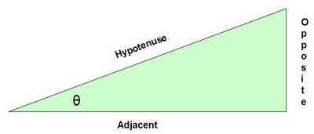](http://4.bp.blogspot.com/_S5dFdpF6xm0/SqPx_Y3NEPI/AAAAAAAAASc/0j6Z6D-ikcA/s1600-h/SOHCAHTOA_trig.jpg)  
  
**"SOHCAHTOA"** is a useful mnemonic for remembering the definitions of the trigonometric functions sine, cosine, & tangent:   
**SOH - Sine θ = opposite over hypotenuse.**   
 **CAH - Cosine θ = adjacent over hypotenuse.**   
 **TOA - Tangent θ = opposite over adjacent.**

|  |  |  |  |  |  |  |  |  |  |  |  |  |
| --- | --- | --- | --- | --- | --- | --- | --- | --- | --- | --- | --- | --- |
| **0** | **1** | **2** | **3** | **4** | **5** | **6** | **7** | **8** | **9** | **10** | **11** | **12** |
| **1** |  |  |  |  |  |  |  |  |  |  |  |  |
| **2** |  |  |  |  |  |  |  |  |  |  |  |  |
| **3** |  |  |  |  |  |  |  |  |  |  |  |  |
| **4** |  |  |  |  |  |  |  |  |  |  |  |  |
| **5** |  |  |  |  |  |  |  |  |  |  |  |  |
| **6** |  |  |  |  |  |  |  |  |  |  |  |  |
| **7** |  |  |  |  |  |  |  |  |  |  |  |  |
| **8** |  |  |  |  |  |  |  |  |  |  |  |  |
| **9** |  |  |  |  |  |  |  |  |  |  |  |  |
| **10** |  |  |  |  |  |  |  |  |  |  |  |  |
| **11** |  |  |  |  |  |  |  |  |  |  |  |  |
| **12** |  |  |  |  |  |  |  |  |  |  |  |  |

Multiplication Table

Multiply the column number by the row number and fill in the answer number to complete the multiplication table.

***DRAW and WRITE about the NUMBERS***

1. **Draw a table or chart that represents 9/11.**

**2. Shade in 3/6**

|  |
| --- |
|  |
|  |
|  |
|  |
|  |
|  |

**3.** **Write the fraction for**

|  |  |  |  |  |
| --- | --- | --- | --- | --- |
|  |  |  |  |  |

**4. Write the alphabetic expression for ¼ (example 1/2 is one-half)**

**5. Write the alphabetic sentence for example 2+2=4.**

**txtaddition**

**2 + 9 = 17 - 6**

**5. Write the alphabetic expression for 7/9**

**Flow Chart Practice Drag and Drop**

Drag the boxes to make a flow chart with examples on how to solve equations.

*Copy the arrows you need.*

**Isolate the Terms that Contain the Variable**

**Steps for Solving Equations**

**Combine Like Terms**

**Isolate the Variable You Wish to Solve For**

**Substitute Your Answer into the Original Equation**

Combine like terms and simplify

3z + 5 +2z = 12 + 4z

Solve the following equation for the variable in the equation.

38 =*z* + 15

*a*+ 12 = *b*,   and *a*= 9,   find the value for *b*.

Solve the following equation for the variable in the equation.

9*x* + 3 = 8*x* + 19

Solve the equation for *x*.

(2/5) *x* = 8

**3 on 3**

Try to fill in the missing numbers in the puzzle below.

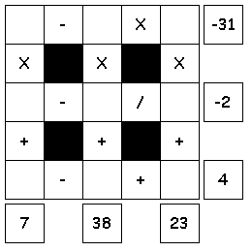

**Use the numbers 1 through 9 to complete the equations.**

**Each number is only used once.  
Each row is a math equation. Each column is a math equation.  
Remember that multiplication and division are performed before addition and subtraction.**

**Three by Three**

Try to fill in the missing numbers in the puzzle below.

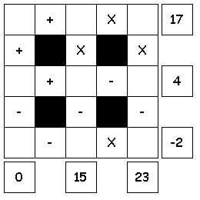

**Use the numbers 1 through 9 to complete the equations. Each number is only used once.  
Each row is a math equation. Each column is a math equation.  
Remember that multiplication and division are performed before addition and subtraction.**

**MATH WORD SORT**

From the Word Bank on the other side of the page, choose at least five words with similar meanings that you can group. Choose three different groups of math words or phrases, title and explain below why they belong in each group. Complete with sentences preferred.

Word Group Title 1: _________________________

____________________________________________________________________________________________________________________________________________________________________________________________________________________________________________________________________________________________________________________________________________________________

Word Group Title 2: _________________________

____________________________________________________________________________________________________________________________________________________________________________________________________________________________________________________________________________________________________________________________________________________________

Word Group Title 3: _________________________

____________________________________________________________________________________________________________________________________________________________________________________________________________________________________________________________________________________________________________________________________________________________

**Word Bank**

|  |  |  |
| --- | --- | --- |
| **add** | **change (for money)** | **left** |
| **all together** | **Decrease** | **less than** |
| **and** | **decrease by** | **nearer** |
| **cut** | **Total** | **is equal to** |
| **both** | **Difference** | **reduce** |
| **combined** | **Farther** | **remain/remaining** |
| **twice** | **the result is** | **average** |
| **how many in all** | **how many more** | **left** |
| **is** | **Whole** | **multiply** |
| **quotient** | **Smaller** | **every** |
| **in all** | **how many less** | **so on** |
| **increased by** | **how much left** | **each** |
| **split** | **times (as much)** | **yields** |
| **is the same as** | **Increase** | **less than** |
| **in all** | **More** | **nearer** |
| **of** | **more than** | **reduce** |
| **product of** | **Plus** | **remain/remaining** |
| **divide** | **Sum** | **Total** |

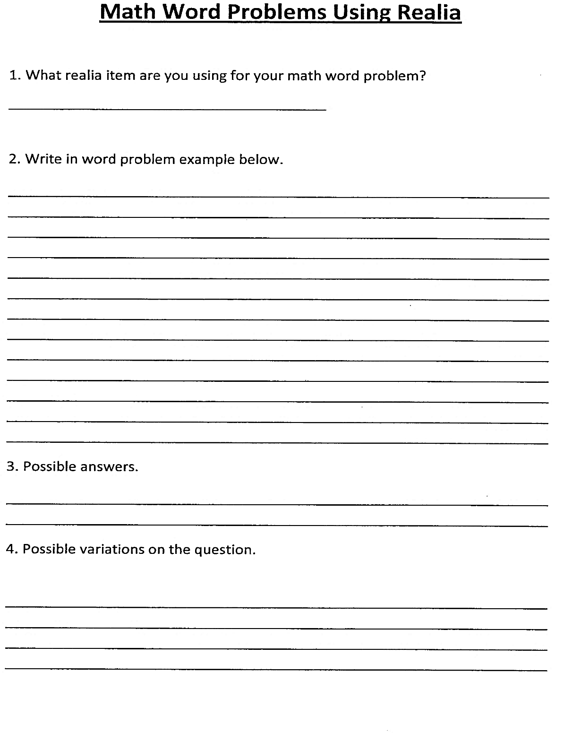

**WORD PROBLEMS MULTIPLYING FRACTIONS**

|  |  |
| --- | --- |
| **1. Mom bought table and chairs for 4/8 of the money she saved - the cost of the table is 5/9 of the amount she spent. What part of her savings she spent for table?  Try: What is the cost of chairs in the amount she spent, in fraction? What part of her savings she spent for chairs?** |  |
| **2. Kate gave 6/7 of her marbles to Tom and Jesse. Of that, Tom got 2/4 of marbles. What part of her marbles Kate gave Tom?  Try: What part of her marbles Kate gave Jesse?** |  |
| **3. 1/2 of the auditorium is filled with students and the rest are teachers and parents. Of the students, 3/7 is boys. What fraction of auditorium is filled with boy students?  Try: What fraction of auditorium is filled with girl students?** |  |
| **4. A grocery store received 90 bags one day. 1/6 of the bags were vegetables and the rest baking items. Of the vegetable bags , 1/3 is potatoes. What part of bags they received were potatoes? How many bags of potato the store received on that day? Try: What part of the bags were baking items and how many?** |  |

***Number Stumpers***

This activity is bound to get your gray matter moving. Using the clues given for each number, figure out the number answer for each question.

1. Clues 1: It is an odd two-digit number.

2: The sum of its digits is 8.

3: The sum of the squares of its digits is 50.

The answer is       .

2. Clues 1: It is an odd two-digit number.

2: The product of its two digits is 24.

3: When the second digit is subtracted from the first, the difference is 5.

The answer is       .

3. Clues 1: It is an even two-digit number.

2: One-half the number is 5 more than the number of days in a fort-night.

3: The sum of the squares of the two digits is 73.

The answer is       .

4. Clues 1: It is an odd two-digit number.

2: The difference of the two digits is 5.

3: The difference in the squares of the two digits is 45.

The answer is       .

5. Clues 1: It is an even two-digit number.

7. Clues 1: It is a palindromic three-digit number.

2: The sum of the digits’ squares is 99.

3: The sum of its digits is 15.

The answer is ___________ .

**Bonus** Clue: Turn the number upside down and it spells a women’s name.

2: The sum of the two digits is 10.

3: The difference of the two digits is 10.

The answer is       .

6. Clues 1: It is an odd two-digit number.

2: The sum of the two digits is 10.

3: The difference of the two digits is 0.

The answer is       .

**Math @ the Movies -** Read the questions below, solve on a separate sheet of paper and then select the answer from the drop-down list to the right. Then choose the corresponding letter in the drop-down list to the left.

|  |  |  |  |  |  |  |
| --- | --- | --- | --- | --- | --- | --- |
| **Number and Letter Bank** | | | | | | |
| **A = 1** | **B = 2** | **C = 3** | **D = 4** | **E = 5** | **F = 6** | **G = 7** |
| **H = 8** | **I = 9** | **J = 10** | **K = 11** | **L = 12** | **M = 13** | **N = 14** |
| **O = 15** | **P = 16** | **Q = 17** | **R = 18** | **S = 19** | **T = 20** | **U = 21** |
|  | **V = 22** | **W = 23** | **X = 24** | **Y = 25** | **Z = 26** |  |

**Movie #1**

**Choose an item. The number of U.S. states minus 30. Choose an item.**

**Choose an item. The number in a quartet plus two squared. Choose an item.**

**Choose an item. The number of events in a pentathlon. Choose an item.**

**Choose an item. The number of days in a fortnight plus five. Choose an item.**

**Choose an item. 1/4 of the minutes in an hour. Choose an item.**

**Choose an item. Its Roman numeral equivalent is XXI. Choose an item.**

**Choose an item. The number of lines in a sonnet. Choose an item.**

**Choose an item. 1/3 of the number of days of Christmas. Choose an item.**

**Choose an item. Its square is 225. Choose an item.**

**Choose an item. It is the number of people in 2 trios. Choose an item.**

**Choose an item. Very few buildings have this floor number. Choose an item.**

**Choose an item. 9 + 6 + 3 + 3. Choose an item.**

**Choose an item. One less than a score. Choose an item.**

**Choose an item. 3 squared. Choose an item.**

**Choose an item. 1/27 of 81. Choose an item.**

**Movie #2**

**Choose an item. An even dozen. Choose an item.**

**Choose an item. The number of Great Lakes. Choose an item.**

**Choose an item. 4% of 500. Choose an item.**

**Choose an item. The number in an octet. Choose an item.**

**Choose an item. The difference between a triad and a duo. Choose an item.**

**Choose an item. The number of sides on a dodecagon. Choose an item.**

**Choose an item. Its square root is 4.79583. Choose an item.**

**Choose an item. The number is the hundreds’ column in 6,543. Choose an item.**

**Choose an item. The number of audible letters in the word queue. Choose an item.**

**Choose an item. A baker’s dozen plus three. Choose an item.**

**Choose an item. 5 less than a score. Choose an item.**

**Choose an item. Half of the days in February in a non-leap year. Choose an item.**

**Movie #3**

**Choose an item. It’s 3/7 of 42. Choose an item.**

**Choose an item. Its cube is 3,375. Choose an item.**

**Choose an item. This number times 3.75 is 11.25. Choose an item.**

**Choose an item. When squared, cubed, and quadrupled, its results are all palindromes. Choose an item.**

**Choose an item. The next perfect square after 16. Choose an item.**

Writing Formulas

Example:

The total price **X** sales tax percentage **=** sales tax amount

Sales tax amount **=** the total price **X** sales tax percentage

Sales tax amount **=** $50 **X** 6.5%

Sales tax amount **=** $50 **X** 0.065

1. Write a formula for the total price of two items.

Item A = $5.00 and item B = $6.65. Write the formula in words and in numbers.

1. Write a formula for the total price of 6 of the same item. Item C = $8.40. Write the formula in words and in numbers.
2. Write a formula for the total price of 6 of the same item with tax. Item D= $4.00 and the sales tax = 6%. Write the formula in words and in numbers

**Fahrenheit & Celsius Cooking**

**Complete the chart below by finding the missing temperatures using the formulas below.**

**Estimated Cooking Temperature in Celsius and Fahrenheit**

|  |  |  |
| --- | --- | --- |
| ***Fahrenheit & Celsius in Cooking*** | **Celsius** | **Fahrenheit** |
| ***Formulas* 🖝** |  |  |
| **Beef Steak - Medium Rare** | **65** |  |
| **Beef Steak - Medium** |  | **158** |
| **Beef Steak - Well Done** | **75** |  |
| **Ground Beef** |  | **158** |
| **Chicken** |  | **185** |
| **Turkey** |  | **185** |
| **Pizza (oven)** | **230** |  |
| **Ham (oven)** |  | **400** |
| **Salmon (oven)** | **110** |  |

**🞟Round to the nearest degree**

**Xs and Ys**

**Use the math clue words to setup the expression and the select from the six possibilities by clicking on choose and drop-down arrow.**

|  |  |  |  |  |  |  |  |
| --- | --- | --- | --- | --- | --- | --- | --- |
| Complete Activity Below  Choose from the operations below to answer questions in column A. | | | | | | | |
| 1. X + Y | | | 1. **X - Y** | | | 1. **Y - X** | |
| 1. XY | | | 1. **X/Y** | | | 1. **Y/X** | |
| # | **Column A** | **Column B** | | # | **Column A** | | **Column B** |
| 1 | Choose | **Y decreased by X** | | 13 | Choose | | **Ratio of X to Y** |
| 2 | Choose | **X goes into Y** | | 14 | Choose | | **X more than Y** |
| 3 | Choose | **X times Y** | | 15 | Choose | | **X added to Y** |
| 4 | Choose | **Difference between**  **X and Y** | | 16 | Choose | | **Y less than X** |
| 5 | Choose | **X multiplied by Y** | | 17 | Choose | | **X reduced by Y** |
| 6 | Choose | **Quotient of X and Y** | | 18 | Choose | | **X increased by Y** |
| 7 | Choose | **X divided into Y parts** | | 19 | Choose | | **Subtract X from Y** |
| 8 | Choose | **Product of X and Y** | | 20 | Choose | | **Exceeds Y by X** |
| 9 | Choose | **Divide X into Y** | | 21 | Choose | | **Y subtracted by X** |
| 10 | Choose | **X divided by Y** | | 22 | Choose | | **X greater than Y** |
| 11 | Choose | **Y less than X** | | 23 | Choose | | **Difference of X and Y** |
| 12 | Choose | **Sum of X and Y** | | 24 | Choose | | **Divide X by Y** |
| C:\Users\mmatos\AppData\Local\Microsoft\Windows\Temporary Internet Files\Content.IE5\X91GI7LX\MP900390099[1].jpg | | | |  | | | |

Solutions

|  |  |  |  |  |  |  |  |
| --- | --- | --- | --- | --- | --- | --- | --- |
| Complete Activity Below  Choose from the operations below to answer questions in column A. | | | | | | | |
| 1. X + Y | | | 1. **X - Y** | | | 1. **Y - X** | |
| 1. XY | | | 1. **X/Y** | | | 1. **Y/X** | |
| # | **Column A** | **Column B** | | # | **Column A** | | **Column B** |
| 1 | **iii.** | **Y decreased by X** | | 13 | **v.** | | **Ratio of X to Y** |
| 2 | **vi.** | **X goes into Y** | | 14 | **ii.** | | **X more than Y** |
| 3 | **iv.** | **X times Y** | | 15 | **i.** | | **X added to Y** |
| 4 | **ii.** | **Difference between**  **X and Y** | | 16 | **ii.** | | **Y less than X** |
| 5 | **iv.** | **X multiplied by Y** | | 17 | **ii.** | | **X reduced by Y** |
| 6 | **v.** | **Quotient of X and Y** | | 18 | **i.** | | **X increased by Y** |
| 7 | **vi.** | **X divided into Y parts** | | 19 | **iii.** | | **Subtract X from Y** |
| 8 | **iv.** | **Product of X and Y** | | 20 | **i.** | | **Exceeds Y by X** |
| 9 | **vi.** | **Divide X into Y** | | 21 | **iii.** | | **Y subtracted by X** |
| 10 | **v.** | **X divided by Y** | | 22 | **ii.** | | **X greater than Y** |
| 11 | **ii.** | **Y less than X** | | 23 | **ii.** | | **Difference of X and Y** |
| 12 | **i.** | **Sum of X and Y** | | 24 | **v.** | | **Divide X by Y** |
|  | | | |  | | | |

C:\Users\mmatos\AppData\Local\Microsoft\Windows\Temporary Internet Files\Content.IE5\3KCFHW4C\MC900023522[1].wmf**Electrician’s Math**

Electricians design, develop, test, or supervise the manufacturing and installation of electrical equipment, components, or systems for commercial, industrial, military, or scientific use. Use the formulas and a calculator if needed to complete conversions below.

|  |  |  |
| --- | --- | --- |
| Electrician’s Formulas | | |
| *W $÷$ 110 = AMPS* | ***W $÷$ 1,000 = KW*** | ***KW $÷$.110 = AMPS*** |
| *AMPS x 110 = W* | ***KW x 1,000 = W*** | ***AMPS x .110 = KW*** |

|  |  |  |  |
| --- | --- | --- | --- |
| *Electronic Item* | *Watts/W* | *Kilowatts/KW* | *Amperes/AMPS* |
| Dishwasher | **400** | ***.4*** | ***3.6*** |
| *Formulas* |  | ***W $÷$ 1,000 = KW*** | ***KW $÷$.110 = AMPS*** |
| Electric Grill |  |  | **15** |
| *Formulas* |  |  |  |
| Electric Oven | **7500** |  |  |
| *Formulas* |  |  |  |
| Garbage Disposal |  |  | **6** |
| *Formulas* |  |  |  |
| Microwave |  | **16** |  |
| *Formulas* |  |  |  |
| Refrigerator |  |  | **8** |
| *Formulas* |  |  |  |
| Toaster | **700** |  |  |
| *Formulas* |  |  |  |
| TV - 32" Color | **170** |  |  |
| *Formulas* |  |  |  |
| Vacuum Cleaner |  | **4** |  |
| *Formulas* |  |  |  |
|  |  |  |  |

**Solutions**

|  |  |  |  |
| --- | --- | --- | --- |
| Electronic Item | Watts/W | Kilowatts/KW | Amperes/AMPS |
| Dishwasher | **400** | ***.4*** | ***3.63*** |
| *Formulas* |  | **W $÷$ 1,000 = KW** | **KW $÷$.110 = AMPS** |
| Electric Grill | ***1650*** | ***1.65*** | **15** |
| *Formulas* | **KW x 1,000 = W** | **AMPS x .110 = KW** |  |
| Electric Oven | **7500** | ***7.5*** | ***68.18*** |
| *Formulas* |  | **W $÷$ 1,000 = KW** | **KW $÷$.110 = AMPS** |
| Garbage Disposal | ***660*** | ***.66*** | **6** |
| *Formulas* | **AMPS x 110 = W** | **AMPS x .110 = KW** |  |
| Microwave | ***16000*** | **16** | ***145.45*** |
| *Formulas* | **KW x 1,000 = W** |  | **KW $÷$.110 = AMPS** |
| Refrigerator | ***880*** | ***.88*** | **8** |
| *Formulas* | **AMPS x 110 = W** | **AMPS x .110 = KW** |  |
| Toaster | **700** | ***.70*** | ***6.36*** |
| *Formulas* |  | **W $÷$ 1,000 = KW** | **KW $÷$.110 = AMPS** |
| TV - 32" Color | **170** | ***.17*** | ***1.55*** |
| *Formulas* |  | **W $÷$ 1,000 = KW** | **KW $÷$.110 = AMPS** |
| Vacuum Cleaner | ***4000*** | **4** | ***36.36*** |
| *Formulas* | **KW x 1,000 = W** |  | **KW $÷$.110 = AMPS** |
|  |  |  |  |

**So you think a gallon of gas is expensive?**

**Most of us are aware of the cost of a gallon of gas or milk. However, it would be interesting to calculate the cost of a gallon of other frequently used items.**

**Complete the chart below.**

**Remember, like in real life situations units of measurement are not always the same. Look at the conversions below the table for help.**

|  |  |  |
| --- | --- | --- |
| ***Item*** | ***Price per container*** | ***Price per Gallon*** |
| **Diet Snapple** | **16 oz. for $1.29** |  |
| **Half & Half** | **1 pint for $ 1.99** |  |
| **Ice Tea** | **16 oz. for $1.19** |  |
| **Gatorade** | **20 oz. for $1.59** |  |
| **Tomato Juice** | **1 quart for $3.99** |  |
| **Ocean Spray** | **16 oz. for $1.25** |  |
| **Pint of milk** | **16 oz. for $1.59** |  |
| **Olive oil** | **1 pint for $3.99** |  |
| **STP Brake Fluid** | **12 oz. for $3.15** |  |
| **Vick’s Nyquil** | **6 oz. for $8.35** |  |
| **Pepto Bismol** | **4 oz. for $3.85** |  |
| **Whiteout** | **7 oz. for $1.39** |  |
| **Clorox Bleach** | **1 quart for $1.50** |  |
| **Scope** | **1.5 oz. for $0.99** |  |
| **Evian water** | **9 oz. for $1.49** |  |

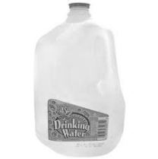

**1 pint = 16 ounces (oz.)**

**1 quart = 32 ounces**

**1 gallon = 128 ounces**

**1 gallon = 4 quarts**

**Solutions:**

|  |  |  |
| --- | --- | --- |
| ***Item*** | ***Price per container*** | ***Price per Gallon*** |
| **Diet Snapple** | **16 oz. for $1.29** | **$10.32** |
| **Half & Half** | **1 pint for $ 1.99** | **$15.92** |
| **Ice Tea** | **16 oz. for $1.19** | **$9.52** |
| **Gatorade** | **20 oz. for $1.59** | **$10.24** |
| **Tomato Juice** | **1 quart for $3.99** | **$15.96** |
| **Ocean Spray** | **16 oz. for $1.25** | **$10.00** |
| **Pint of milk** | **16 oz. for $1.59** | **$12.72** |
| **Olive oil** | **1 pint for $3.99** | **$31.92** |
| **STP Brake Fluid** | **12 oz. for $3.15** | **$33.60** |
| **Vick’s Nyquil** | **6 oz. for $8.35** | **$177.92** |
| **Pepto Bismol** | **4 oz. for $3.85** | **$122.88** |
| **Whiteout** | **7 oz. for $1.39** | **$25.60** |
| **Clorox Bleach** | **1 quart for $1.50** | **$6.00** |
| **Scope** | **1.5 oz. for $0.99** | **$84.48** |
| **Evian water** | **9 oz. for $1.49** | **$21.76** |

**It’s Raining Quarters, Dimes, Nickels, and Pennies**

In column **A.** is the amount of money; in column **B.** is the number of coins that make up the first column’s amount. In the spaces provided in under column **C.**, write the number of coins that make up column **A.**’s amount. The coins are quarters (**Q**), dimes (**D**), nickels (**N**), and pennies (**P**). The first question has been completed as an example.

|  |  |  |  |  |  |  |  |
| --- | --- | --- | --- | --- | --- | --- | --- |
| # | 1. Money Amount | 1. Coin Amount | |  |  |  |  | | --- | --- | --- | --- | | Q | D | N | P | |
| 1. | **25¢** | **5** | |  |  |  |  | | --- | --- | --- | --- | | **0** | **0** | **5** | **0** | |
| 2. | **35¢** | **7** | |  |  |  |  | | --- | --- | --- | --- | |  |  |  |  | |
| 3. | **33¢** | **8** | |  |  |  |  | | --- | --- | --- | --- | |  |  |  |  | |
| 4. | **46¢** | **5** | |  |  |  |  | | --- | --- | --- | --- | |  |  |  |  | |
| 5. | **56¢** | **7** | |  |  |  |  | | --- | --- | --- | --- | |  |  |  |  | |
| 6. | **17¢** | **4** | |  |  |  |  | | --- | --- | --- | --- | |  |  |  |  | |
| 7. | **43¢** | **6** | |  |  |  |  | | --- | --- | --- | --- | |  |  |  |  | |
| 8. | **29¢** | **7** | |  |  |  |  | | --- | --- | --- | --- | |  |  |  |  | |
| 9. | **54¢** | **8** | |  |  |  |  | | --- | --- | --- | --- | |  |  |  |  | |
| 10. | **57¢** | **7** | |  |  |  |  | | --- | --- | --- | --- | |  |  |  |  | |
| 11. | **48¢** | **7** | |  |  |  |  | | --- | --- | --- | --- | |  |  |  |  | |
| 12. | **34¢** | **8** | |  |  |  |  | | --- | --- | --- | --- | |  |  |  |  | |

**Cha.. Cha.. Cha.. Cha.. Changes**

**Below are three groups of coins. Your challenge: As coins are shuffled in and out of these groups, see if you can figure out how much money is in each group each time. Each numbered challenge tells you some necessary information and then ask you to fill in the omitted numbers to solve each problem.**

**Coins used: Pennies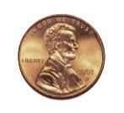, Nickels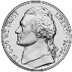,** **Dimes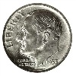, Quarters** 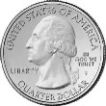

**Write your answers in the spaces provided. The first question group has been completed as an example.**

|  |  |  |  |  |
| --- | --- | --- | --- | --- |
|  | GROUP 1 | GROUP 2 | GROUP 3 | GROUP 4 |
| 1. | **2 coins**  **11¢** | **3 coins**  **16¢** | **4 coins**  **12¢** | **9 coins**  **39¢** |
| The total number of dimes in the three groups above is . | | | | |
|  | GROUP 1 | GROUP 2 | GROUP 3 | GROUP 4 |
| 2. | **coins**  **45¢** | **coins**  **26¢** | **5 coins**  **¢** | **12 coins**  **89¢** |
| The total number of nickels in the three groups above is . | | | | |
|  | GROUP 1 | GROUP 2 | GROUP 3 | GROUP 4 |
| 3. | **7 coins**  **¢** | **coins**  **31¢** | **3 coins**  **¢** | **coins**  **91¢** |
| The total number of quarters in the three groups above is . | | | | |
|  | GROUP 1 | GROUP 2 | GROUP 3 | GROUP 4 |
| 4. | **coins**  **37¢** | **5 coins**  **27¢** | **5 coins**  **¢** | **coins**  **$1.10** |
| The total number of pennies in the three groups above is .  http://ts4.mm.bing.net/images/thumbnail.aspx?q=4657991493747763&id=b1215d838f02de1f76588f2f403e3fcehttp://ts4.mm.bing.net/images/thumbnail.aspx?q=4575334844663207&id=2e4fba395082c2799a824faf71b1ce7fhttp://ts3.mm.bing.net/images/thumbnail.aspx?q=4932341112832302&id=b38b09ffb73203227500fc38c7a31dfehttp://ts2.mm.bing.net/images/thumbnail.aspx?q=5023828206945717&id=07fb5c560994192fb5d3db08e50702a3http://ts4.mm.bing.net/images/thumbnail.aspx?q=4657991493747763&id=b1215d838f02de1f76588f2f403e3fcehttp://ts4.mm.bing.net/images/thumbnail.aspx?q=4575334844663207&id=2e4fba395082c2799a824faf71b1ce7f | | | | |

**$10 Rates**

**Directions:**

The longer your money sits in the bank, the more money it will earn for you. The money earnedis called interest. The higher the interest rate, the more money you earn. Fill in the chart below,assuming you are figuring out the money earned on a deposit of $10 (for simple interest).

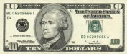

Future Value of money: $10.00

|  |  |  |  |
| --- | --- | --- | --- |
| **Years** | **5%** | **8%** | **10%** |
| **1 year** |  |  |  |
| **3 years** |  |  |  |
| **5 years** |  |  |  |
| **10 years** |  |  |  |
| **15 years** |  |  |  |
| **20 years** |  |  |  |

**Use ☞ Interest Rate Formula: Interest (I) =**

**Principal(P) x Rate(R) x Time(T)**

**I = PRT**

***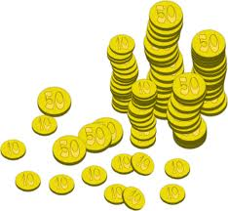*Money - What’s Probable?**

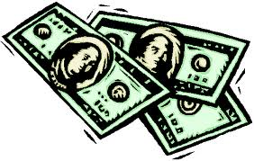

***Money – Coin and Paper***

**1. In two tosses of the same penny, what are the chances they will both be heads?**

1. **1/8**
2. **1/4**
3. **1/2**
4. **1/16**
5. **1**

**2. In two tosses of the same penny, what are the chances that you will get a combination of one head and one tail?**

1. **2 out of 4**
2. **3 out of 4**
3. **1 out of 8**
4. **4 out of 4**
5. **4 out of 8**

**3. In three tosses of the same penny, what are the chances of getting three tails?**

1. **1 out of 4**
2. **1 out of 9**
3. **1 out of 3**
4. **1 out of 6**
5. **1 out of 8**

**4. Beth has 14 coins in her pocket. The probability of pulling out a penny is 1/2. How many pennies are in her pocket? Express the probability in three ways:**

1. **Express as a fraction**

1. **Express as a decimal**

The Penny Worksheet

|  |  |
| --- | --- |
| **One a Penny** | |
| One a penny, | Six a penny, |
| Two a penny, | Seven a penny, |
| Three a penny, | Eight a penny, |
| More, | More, |
| Four a penny, | Nine a penny, |
| Five a penny, | Ten a penny, |
| That's a nickel more | That's a dime for the store! |

|  |  |  |
| --- | --- | --- |
| **Day & Pennies** | **Exponent** | **Total Amount** |
| **1** | **11** | **$ 0.01** |
| **2** | **22** | **$ 0.04** |
| **3** | **33** | **$ 0.27** |
| **4** |  |  |
| **5** |  |  |
| **6** |  |  |
| **7** |  |  |
| **8** |  |  |
| **9** |  |  |
| **10** |  |  |
| **11** |  |  |
| **12** |  |  |

.

Penny Heads or Tails

Ten Toss Probabilities: Use the interactive coin toss at Shoder.org website

Hold down CTRL key and click on link ☞<http://www.shodor.org/interactivate/activities/Coin/>

1. **Predict:** How many heads and how many tails will show up if you flip the coin 10 times?

Why?

|  |  |  |
| --- | --- | --- |
|  | **Heads (Blue)** | **Tails (Red)** |
| **1** |  |  |
| **2** |  |  |
| **3** |  |  |
| **4** |  |  |
| **5** |  |  |
| **6** |  |  |
| **7** |  |  |
| **8** |  |  |
| **9** |  |  |
| **10** |  |  |

2. What are your odds of tossing heads when you flip a coin? Express your odds as a fraction.       Express it as       out of      . Express it as a percentage:      %

3. Make a bar graph in Excel representing the results of your first 10 flips. Do this bar graph on the worksheet provided click here. Make the number of heads **red** and the tails **green**.

4. Compare your results with the rest of the class. Were their results according to your prediction?

Next, add the results of the whole class. How do the results compare now?

***Recipe for Four - Breaded Steak for One***

**Breaded Steak recipe (Bistec Empanizado) -** serves 4

4 steaks (1/4 inch thick)

1/2 cup onion, chopped

1 tbsp fresh garlic, minced ____________

1/4 cup sour orange juice

1/4 tsp salt ________________

4 eggs, beaten well

1 cup finely ground crackers, salt to taste _________________________________

1/2 onion, sliced into rings

Olive oil

Sprinkle steaks with chopped onion, garlic, orange juice and salt.  Rub garlic into meat.  Marinate for a few hours in the refrigerator. Brush off the onion pieces and dip each steak into the egg to make sure it’s fully coated.  Dip the steak into the crackers, making sure that the ground crackers completely cover the steak.  Fry the steaks in cooking oil on medium heat until golden brown and well done.  Serve with a few onion rings.

**This bachelor has to convert a recipe his mother gave him for breaded steaks recipe that serves four to a recipe that will serve one. Usually a bachelor fridge just has a few half-empty jars of condiments, a flat 2-liter Coke and some old pizza in it, but you need a big fridge for beer parties. A bachelor’s cooking utensils are also limited. There are no tablespoons and measuring cups in this house. Teaspoons and shot glasses have to be used as substitutes.**

**What would the recipe look like if you were only making enough breaded steak to serve one? Please write the correct measurement conversions and translation on the lines above.**

* **1 US tablespoon = 3 US teaspoons**
* **One shot = one ounce**
* **One cup = eight ounces**

**Grocery Shopping 101**

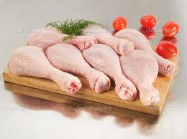 **Choose your answer from the drop downs that follow the questions.**

**CHICKEN LEGS**

NET WT. PRICE PER LB. TOTAL PRICE

6.75 LB. $2.00 $13.50

1. How much does the package cost? Choose an item.
2. How much does it cost per pound? Choose an item.
3. How much does it weigh? Choose an item.
4. How many pounds will I be able to buy with $17.00? Choose an item.

1. What will 9.25 pounds of chicken legs cost? Choose an item.

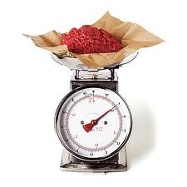

**GROUND BEEF**

TOTAL PRICE: $27.63

PRICE PER LB.: $4.25

NET WT.: 6.5 LBS.

1. How much does the package cost? Choose an item.

1. How much does a pound cost? Choose an item.
2. How much does it weigh? Choose an item.
3. How many pounds of ground beef will I be able to buy with $96.50? Choose an item.
4. What will 4.25 pounds of ground beef cost? Choose an item.

**Then and Now – 1913’s prices verses today’s**

Prices in 1913 were very different than today’s prices. Listed below are some items and their prices in 1913 to shopping today, use the internet to find the cost of the items under today’s prices, then figure out the percentage increase between 1913 and today.

|  |  |  |  |  |
| --- | --- | --- | --- | --- |
| **Items** | **1913 Prices** | **Items** | **Today’s Prices** | **Percentage Increase** |
| 1 dozen eggs | 38 cents (.38) | 1 dozen eggs |  |  |
| Loaf of bread | 6 cents (.06) | Loaf of bread |  |  |
| Compact Car | $1150.00 | Compact Car |  |  |
| Girl’s Dress | $1.65 | Girl’s Dress |  |  |
| Baseball | $1.15 | Baseball |  |  |
| Bicycle | $11.95 | Bicycle |  |  |
| Crayons (28 Colors) | 4 Cents (.04) | Crayons (28 Colors) |  |  |

Why do you think prices are higher today?

**Extended Activity:**

Life in 1913 was very different than it is today. In 1913, there were only 48 states; Alaska and Hawaii had not yet become states. Research and write a report to present to the class about what it would have been like to live in 1913 and try to bring in examples of everyday items and their costs then and today.

**Invoices** Pies by Sara **– Group project**

Sara needs some extra money. She will start selling homemade pies next month. Below is a poster advertising her new pie business:

Pies by Sara

*The best in town!*

Cherry……………$8.00

Strawberry………$10.00

Pumpkin……….…$6.50

Apple…………….$7.75

Peach…………….$9.95

(prices above do not include tax)

MN state sales tax = 6.5% Hennepin County sales tax = 0.5%

245 Minnehaha Ave.

Minneapolis, MN 55406

Phone: 612-483-1763

Fax: 612-483-1764

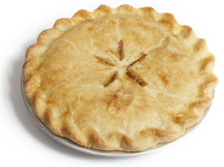

There is a **$5.00 delivery fee** per order.

Orders of 10 or more pies receive a **5% discount** on the total bill

(before tax).

Calculate the totals for these orders:

1. Jan Iverson wants 2 cherry pies and 3 pumpkin pies delivered to her house (2455 Cleveland Ave. South, Saint Paul, MN 55104).
2. Rachel Morris wants 2 of each kind of pie. She will pick them up herself.
3. Margaret Homer wants 15 peach pies delivered to her office (40 East Broadway Ave., Minneapolis, MN 55419)

Sara needs help creating an invoice (a bill) that will automatically calculate the taxes and totals. Follow the directions below to create an invoice using Microsoft Excel.

1. Go to www.microsoftoffice.com
2. On the left side of the screen, click on **TEMPLATES**
3. In the search box type ***invoice that calculates total.***
4. Select the ***invoice that calculates total*** template from the list.
5. Click on **Download Now**.

* You will need to create 3 separate invoices, one for each order.
* You will need to move the TOTAL box down and add boxes for taxes.
* Use formulas to calculate the percentages and the total.
* Check your work.
* Print all 3 invoices.

**Budget Scenarios**

**Scenario 1:**

**Josie Lim has no children but is used to working long hours and never getting errands done. She lives in a tiny studio apartment near Lincoln Park, ($1000/month) but longs to have a house of her own. Josie eats out a lot (7 meals a week @ an average of $7 each meal), takes her clothes to a laundry service ($0.60 a pound @ 20 pounds every 10 days), belongs to a health club ($475/month) and parks in parking garages all day while she works in the loop ($14.70/day). Even though she is a third year apprentice and makes $19.00 an hour, she never seems to have money left over. What are some things Josie can do to start saving up for a down payment on a house someday?**

**Scenario 2:**

**Ivette Jones loves to read and always buys the latest popular books as soon as they come out, usually in hardcover ($22-$35/book). She reads very fast so most of the time she goes through 2 to 3 books a week. Ivette’s favorite place to read is Starbucks, where she spends hours a day after work (3 times a week at least) just drinking and reading ($4/cup @ 2-3 cups a day). She lives alone in a garden apartment ($500/month) and takes the bus to work every day ($3/day). Her boss will let her change her schedule to fit around her pre-apprenticeship program once she gets in. She will be working 10 hours or so a week instead of 40 hours. At $8.00 an hour, that’s $80 a week she’ll be making ($52 a week take home after taxes). How can Ivette cut corners to compensate for unpaid pre-apprenticeship time?**

**Scenario 3:**

**Jennifer Williams is single and has no children. She is on the waiting list for the Carpenter’s pre-apprenticeship program and will start class in about six months. Between now and then she needs to save up for 9 weeks of unpaid training. Right now she works 40 hours a week at Starbucks, making $10.00 an hour. ($6.50 an hour after taxes, otherwise known as take home pay.) Lately she has been trying to work 5 hours of overtime a week, because she keeps coming up short on her bills. Jennifer’s monthly expenses include:**

* **Rent: $650.00**
* **Credit Card: $320.00**
* **Transportation: $100.00**

**Jennifer cannot hang on to her money. Between cigarettes, dining out, cable TV and shopping, she is living beyond her means. Can you help Jennifer save for her pre-apprenticeship without ruining her life?**

**Understanding Nutrition Labels**

Read the nutrition information (nutrition facts) and ingredient contents from a bag of ***SunChips*** and answer the following questions.

1. **How much more is the fat content per serving of regular potato chips than a serving of SunChips?**
2. **How man milligrams of salt are in one serving of SunChips?**
3. **Would eating these chips pose a problem to someone who has an allergic reaction to dairy products? to nuts?**
4. **What us the most abundant vitamin found in SunChips? Where can you find the information to answer this question?**
5. **How many different minerals do SunChips contain? Which mineral(s) is most abundant in SunChips?**
6. **Are there any artificial dyes in the ingredients of SunChips? If so, which ones? Where can you find the information to answer this question?**
7. **About what percent of the total carbohydrate content in this bag of SunChips is sugar? About what percent is fiber?**
8. **About what percent of the total calories of this bag of SunChips are calories from fat?**
9. **How many calories are there in one gram if fat? One gram of carbohydrate? One gram of protein? Where can you find the information to answer this question?**
10. **What is the maximum grams of fat one should eat daily if he or she were on a 2,000 calorie diet? If one were on a 2500 calorie diet?**

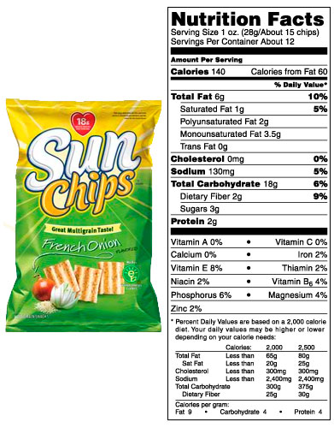

**Planning for Computer Class Group Project**

Michael is planning on offering a new computer class at his agency. Michael assigns James as the instructor for the new computer class twice a week. James starts to plan activities for the computer class. He begins by organizing information about all of the students that have registered for the class. There are 15 students enrolled in the class. In addition to the instructor James, there are 2 volunteers on Monday nights and 1 on Wednesday nights. The class is from 5:30 to 8:30pm and the students take a 20 minute break. The course last for 6 weeks.

As a group (3-5 individuals), write or draw your work on paper and answer to the questions below:



1. Tomorrow Michael is planning a 20 minute warm-up and a 30 minute demonstration. There is a 20 minute break at 7pm. It usually takes about 5 minutes for everyone to shut down their computers at the end of class. How much time will be left for the students to work on their exercises?

A. 30 minutes

B. 1 hour, 20 minutes

C. 1 hour, 45 minutes

D. 1 hour, 15 minutes

2. Michael needs to make a spreadsheet containing the names, phone numbers, e-mail addresses, and mailing addresses of all the students in the class. He needs the city, state, and zip code to be in different **cells**.

On the back of this piece of paper, draw how you would organize this information in an Excel spreadsheet. Write in the information of your group members.

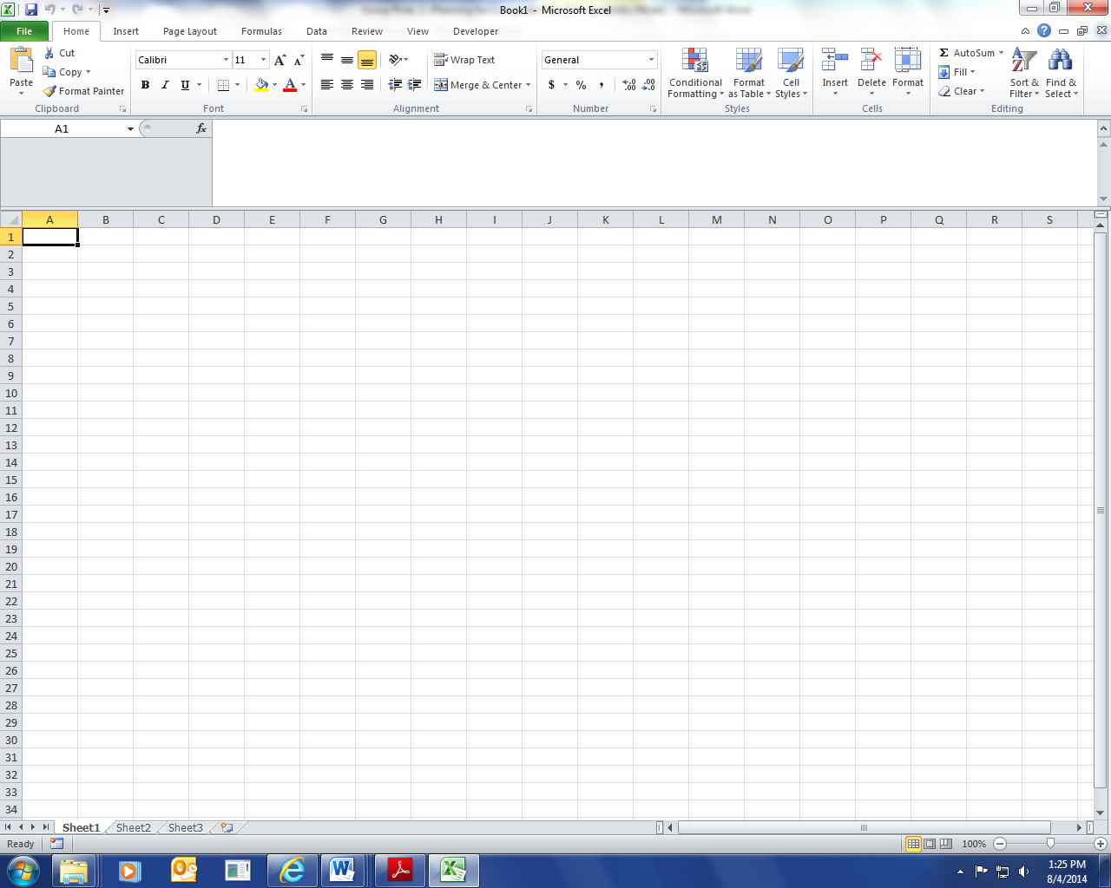

3. If **all** the students in the class had perfect attendance, how many hours of attendance would the students in the class produce at the end of the 6-week course?

A. 720

B. 430

C. 500

D. 540

4. On Wednesday night, if 4 students are absent, how many students will there be per teacher/ volunteer?

A. 7.50

B. 5.75

C. 4.20

D. 5.50

E. 3.75



5. What is the student to teacher ratio?

Click here to enter text.

6. Open a new Excel spreadsheet on the computer. Enter the information from problem #2. If you have time, try **changing the font and font size** of some of the cells. Make the title cells (city, state, zip code) bold. Try **adding a color** to the title cells.

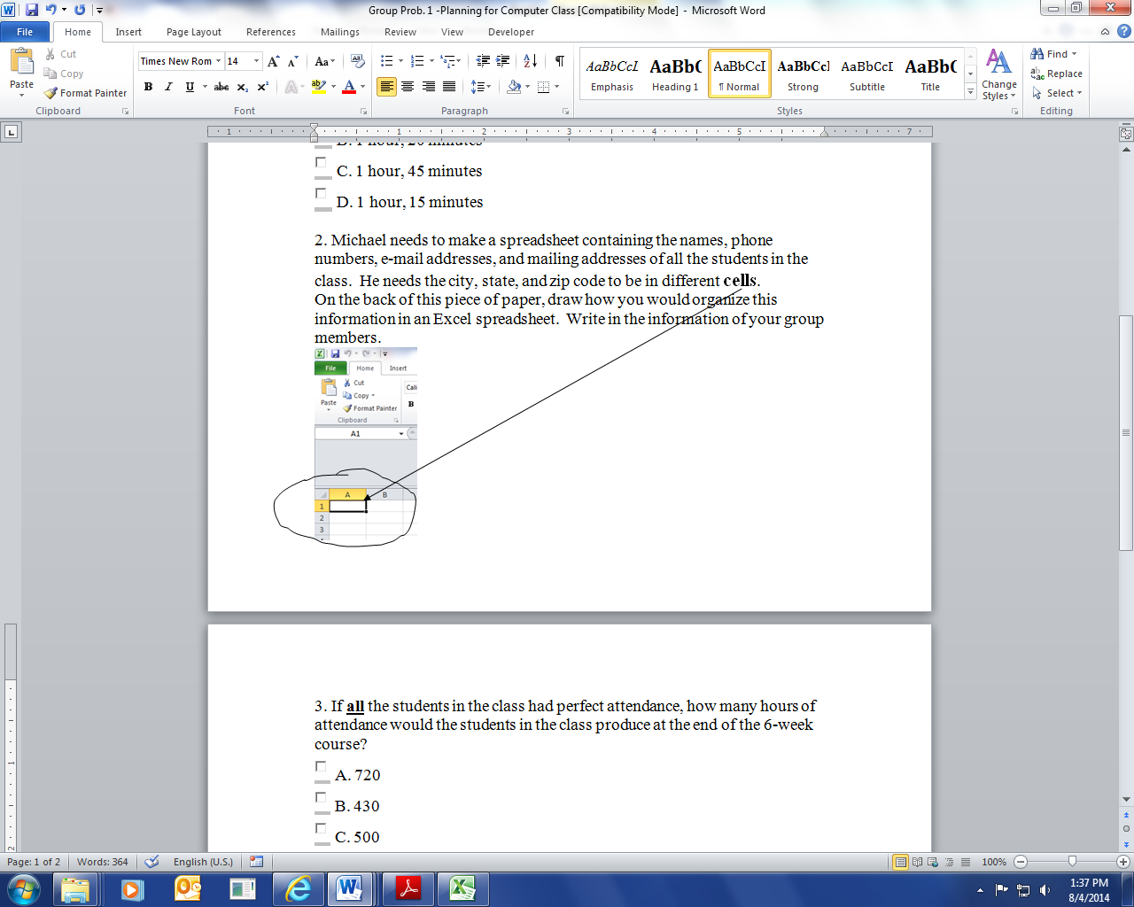

**Floor Area – Square feet and yards**

**Find the floor area in square feet for each of the following floor plans. Omit the closet area in #1 and the bathroom area in #3. Use measuring tape as needed.**

***Formula for area of rectangle: A = L x W***

**Floor plan 1. Floor plan 2. Floor plan 3.**

**Find the floor area in square yards for each of the following floor plans. Omit the closet area in #1 and the bathroom area in #3.**

***One square yard = 9 square feet***

**Floor plan 1. Floor plan 2. Floor plan 3.**

**Drywall -LR estimate 1.** **2.**

Drywall -Bedroom 4

Finish Carp -Office building **3.**

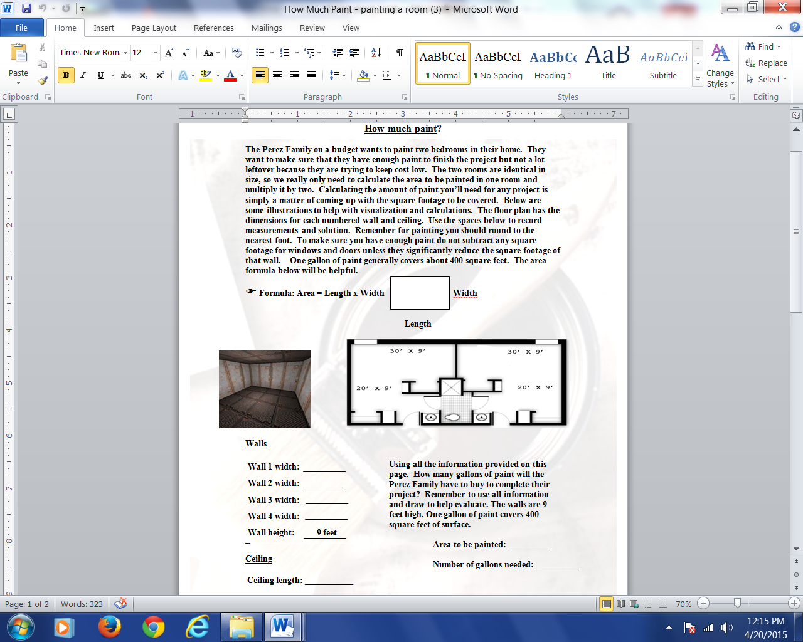

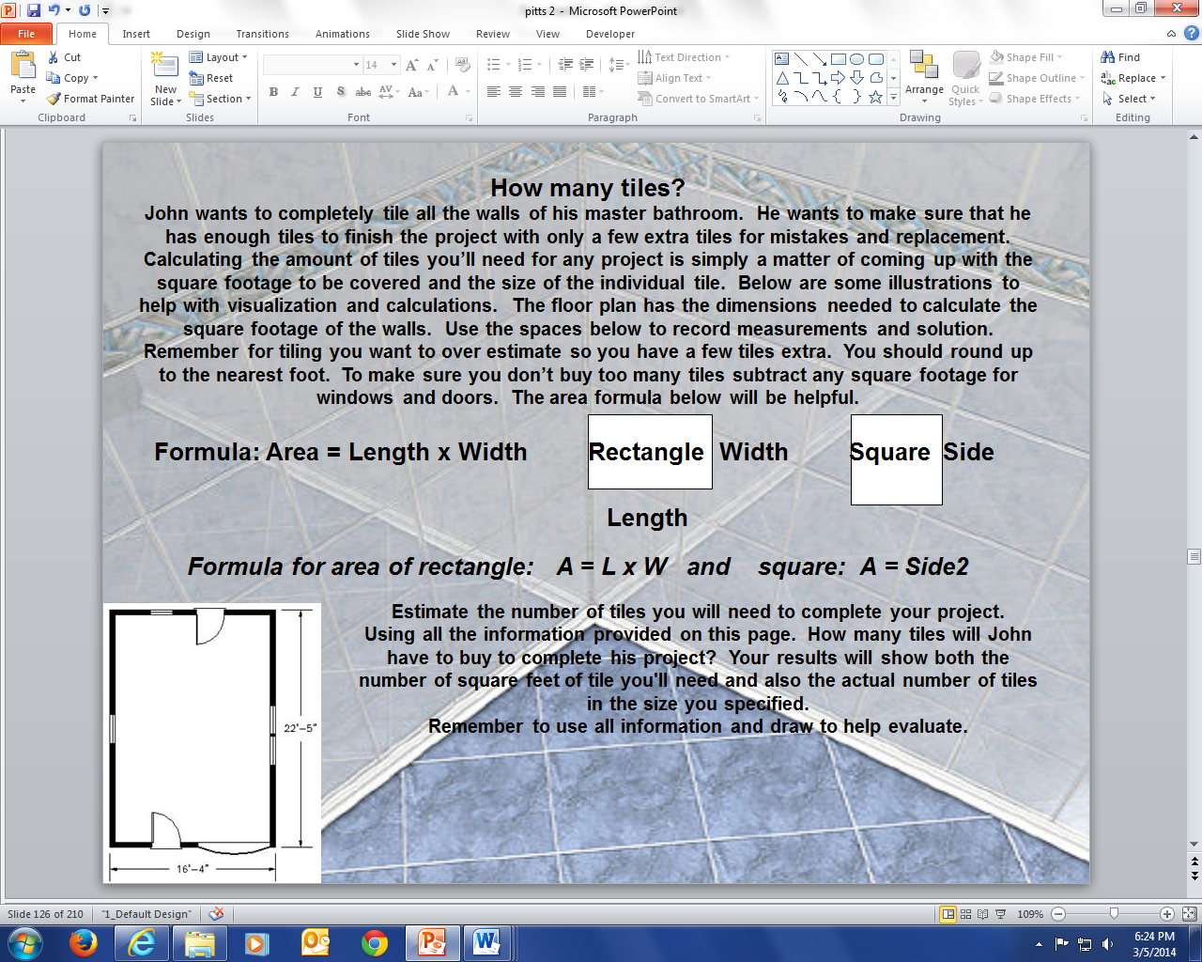

**How much carpet?**

**Tammy and Mike want to carpet their living and dining room area. They want to come up with a quick estimate to make sure they could afford the project. They also want to make sure that they have enough carpet to finish the project. Getting a rough idea of how much carpet you will need for a project is pretty simple, but a precise figure is a little more difficult to come by. Calculating the amount of carpet you’ll need and what it costs means coming up with the square footage and multiplying this measurement by the price per square yard. The price of carpet is usually expressed in square yards.**

***A yard is 3 feet so a square yard equals 3 feet by 3 feet or 9 square feet.***

**Find the area in square footage for the Living/Dining room. After converting to square yards, calculate how much the carpeting will cost. *One square yard of carpeting is equal to $9.99.* Below are some illustrations to help with visualization and calculations. The floor plan has the dimensions needed to calculate the square footage of the area to carpet. Use the spaces below to record measurements and solution. You should round up to the nearest foot. The area formula below will be helpful.**

***☞ Formula for area of rectangle: A = L x W and square: A = Side2***

**Rectangle Width Square Side**

**Length Side**

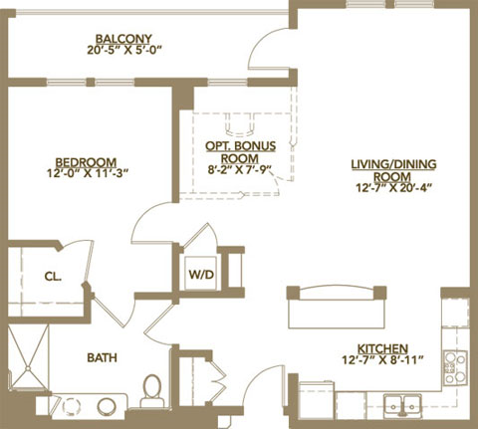

**Width:**

**Length:**

**Square feet needed:**

**Square yards needed:**

**MAP SCALE: FINDING DISTANCES ON A MAP**

Locate the **scale** on the map that you and your partner(s) are assigned. You will use this scale in order to determine the approximate distance and the exact distance between two points on the map. Use the following proportion to determine distances:

One Inch = (Number of Inches)

scale X

**Map # 1: Washington, Oregon, Idaho, Montana, Wyoming**

|  |  |  |
| --- | --- | --- |
| **Map Location Points** | **Approximate Distance** | **Exact Distance** |

|  |  |  |
| --- | --- | --- |
| **1. Seattle, WA—Jackson, WY** |  |  |
| **2. Yellowstone Lake, WY—Crater**  **Lake, OR** |  |  |
| **3. Portland, OR—Boise, ID** |  |  |
| **4. Vancouver, BC—Vancouver, WA** |  |  |
| **5. Coos Bay, OR—Birch Bay, WA** |  |  |
| **6. Billings, MT—Eureka, CA** |  |  |
| **7. Klamath Falls, OR—Idaho Falls, ID** |  |  |
| **8. Butte, MT—Yakima, WA** |  |  |

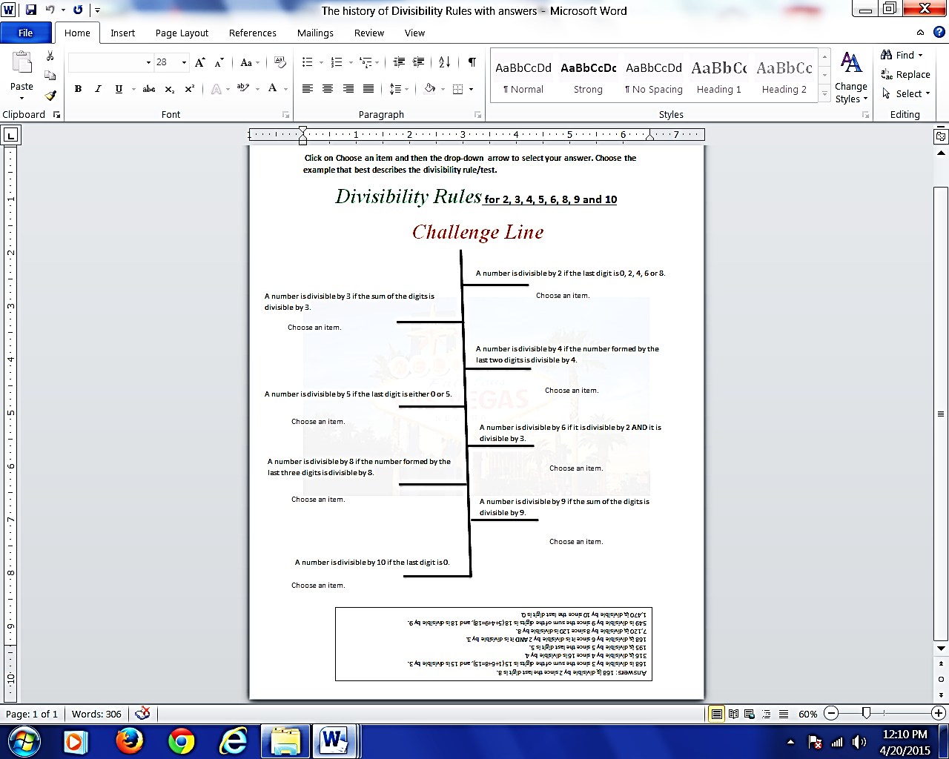

|  |  |  |  |
| --- | --- | --- | --- |
| Instructor: | Michael Matos | Name: |  |
| Class: | i-pathways - hybrid | Date: |  |
| Period: | Spring term | Results: |  |

**Instructions**

Read the poem below and answer the questions that follow by clicking in the correct radio button and typing in the correct letter.

**Part I: Smart Poetry Reading**

Smart

My dad gave me one dollar bill

‘Cause I’m his smartest son,

And I swapped it for two shiny quarters

‘Cause two is more than one!

And then I took the quarters

And traded them to Lou

For three dimes—I guess he don’t know

That three is more than two!

Just then, along came old blind Bates

And just ‘cause he can’t see

He gave me four nickels for my three dimes,

And four is more than three!

And I took the nickels to Hiram Coombs

Down at the seed-feed store,

And the fool gave me five pennies for them,

And five is more than four!

And then I went and showed my dad,

And he got red in the cheeks

And closed his eyes and shook his head---

Too proud of me to speak!

**--- Shel Silverstein From** Where the Sidewalk Ends **HarperCollins Publishers: 1974**